# MINI PROJECT (2020-21)

**JOB BRIDGE**

**MID-TERM REPORT**



**Institute of Engineering & Technology**

**Submitted by-**

**Prakhar Agarwal (181500468)**

**Gaurav Sharma(181500235)**

**Vishal Singh(181500809)**

**Mansi Gupta(181500371)**

**Harsh Yadav (181500250)**

***Supervised By: -***

**Mr. Anand Parkash Gupta**

**Mrs. Ruchi Gupta**

**Asst. Professor**

# Department of Computer Engineering & Application

**Contents**

|  |  |
| --- | --- |
| **Abstract**  **Declaration** | **3**  **4** |
| **1. Introduction** | **5** |
| * 1. General Introduction to the topic * About Web Development * How Web development works * About our Website * What is Frontend web Development * What is Backend Web Development |  |
| 1.2 Area of Computer Science |  |
| 1.3 Hardware and Software Requirements |  |
| **3. Objectives**  **4. Certificate** | **11**  **12** |
| **5. Progress** | **17** |
| **6. Screenshots** | **18** |
| **7. References** | **51** |
|  |  |

**Abstract**

In this we will build a website using the concept of Web Development and designing the website by using the front end and back end technologies in which Front end technology includes HTML,CSS and JavaScript and Back-end technology includes PHP that we have used in our website which makes the site efficient and effective. We have made this website for the use of the college students who are freshers to the college and are unaware about the placements and recruitments in the campus and the skills in demand about the specific companies and the programming languages that are in use by most of the companies. So, our website will give enough information about all of these to the students so that they can get enough knowledge about the campus placements and the knowledge and criteria they need to appear in the placement drives and moreover they can also contact with their seniors who have already appeared or placed in that company about the work at industrial level and the quality of skills needed. You can also communicate with the college faculty of the training and placement department so that you can be regularly updated by the offers and criteria by the companies from time to time and update your skills accordingly. In this you can also calculate you percentage of getting placed in a specific company by comparing your skills with the skills required by the company, it also helps to analyse you interest in a specific company and can attend the drives accordingly.

**Declaration**

We hereby declare that the work which is being presented in the MINI PROJECT **“Title…JOB BRIDGE …”,**in complete fulfillment of the requirements for Mini Project viva voce, is an authentic record of my own work carried under the supervision of **Mr Anand Parkash Gupta and Mrs Ruchi Gupta.**

Signature of Candidates:

Name of Candidate/Roll No: MANSI GUPTA (181500371)

GAURAV SHARMA (181500235)

VISHAL SINGH (181500809)

PRAKHAR AGRAWAL (181500468)

HARSH YADAV (181500250)

Course: B-tech CSE

Year: III

Semester: 5th

# Introduction

* 1. **General Introduction to the topic**

As the title suggests Job Bridge which means a bridge or a gateway that connects the college students to the upcoming opportunities ahead in their college life for the campus placements in the future.

Our goal is to make an efficient and responsive website where students likely in 1st-3rd year can connect to the companies recruiters and with the college faculty to get the information and knowledge about the campus placements, skills in demand, different skills required by different companies, other professional skills that are required in an interview, moreover students can also communicate with their seniors who are currently giving these interviews for the campus placements that how they cleared the interview or why they got rejected so that students could get sufficient knowledge from the very first year and can continue their study accordingly so that more students can get placement offers from good companies.

**About Web Development:**

Web development is the building and maintenance of websites; it’s the work that happens behind the scenes to make a website look great, work fast and perform well with a seamless user experience.

Web developers, or ‘devs’, do this by using a variety of coding languages. The languages they use depends on the types of tasks they are preforming and the platforms on which they are working.

Web development skills are in high demand worldwide and well paid too – making development a great career option. It is one of the easiest accessible higher paid fields as you do not need a traditional university degree to become qualified.

The field of web development is generally broken down into front-end (the user-facing side) and back-end (the server side). Let’s delve into the details.

**How Web Development Works**

A web developer is a programmer who creates programs and applications for the World Wide Web. A web developer knows how to build a website from the bottom up: they can create custom code to accommodate your unique needs, developing everything from the site layout to features and functions on the webpage.

Clients and servers

Computers connected to the web are called clients and servers. A simplified diagram of how they interact might look like this:

Two circles representing client and server. An arrow labelled request is going from client to server, and an arrow labelled responses is going from server to client

Clients are the typical web user's internet-connected devices (for example, your computer connected to your Wi-Fi, or your phone connected to your mobile network) and web-accessing software available on those devices (usually a web browser like Firefox or Chrome).

Servers are computers that store webpages, sites, or apps. When a client device wants to access a webpage, a copy of the webpage is downloaded from the server onto the client machine to be displayed in the user's web browser.

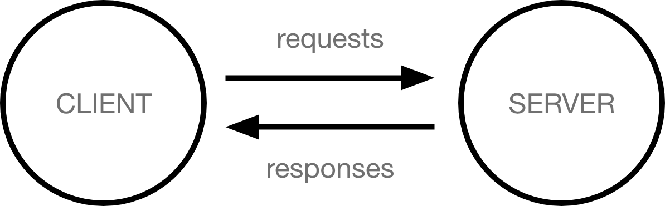

**About Our website:**

As the title suggests Job Bridge which means a bridge or a gateway that connects the college students to the upcoming opportunities ahead in their college life for the campus placements in the future.

Our goal is to make an efficient and responsive website where students likely in 1st-3rd year can connect to the companies recruiters and with the college faculty to get the information and knowledge about the campus placements, skills in demand, different skills required by different companies, other professional skills that are required in an interview, moreover students can also communicate with their seniors who are currently giving these interviews for the campus placements that how they cleared the interview or why they got rejected so that students could get sufficient knowledge from the very first year and can continue their study accordingly so that more students can get placement offers from good companies.

**What is Front hand Web Development:**

Front-end web development, also known as client-side development is the practice of producing HTML, CSS and JavaScript for a website or Web Application so that a user can see and interact with them directly. The challenge associated with front end development is that the tools and techniques used to create the front end of a website change constantly and so the developer needs to constantly be aware of how the field is developing.

The objective of designing a site is to ensure that when the users open up the site they see the information in a format that is easy to read and relevant. This is further complicated by the fact that users now use a large variety of devices with varying screen sizes and resolutions thus forcing the designer to take into consideration these aspects when designing the site. They need to ensure that their site comes up correctly in different browsers (cross-browser), different operating systems (cross-platform) and different devices (cross-device), which requires careful planning on the side of the developer.

**What is Backend development:**

Back-end development includes the server implementation and it more on the logical interaction of data, how it is stored, and transmitted. Back-end developers typically work with programming languages such as PHP, Python, Go, and new Javascript libraries like Node.

This is where the data is stored, and without this data, there would be no frontend. The backend of the web consists of the server that hosts the website, an application for running it and a database to contain the data.

The backend dev uses computer programmes to ensure that the server, the application and the database run smoothly together. This type of dev need to analyse what a company’s needs are and provide efficient programming solutions. To do all this amazing stuff they use a variety of server-side languages, like PHP, Ruby, Python and Java.

* 1. **Area Of Computer science**

1. **Maintaining Ownership**

It’s critical to protect your brand identity by owning your web address and website. This will avoid surrendering control of your brand to a third party website and their ads. Remember, owning your own domain name and using a reputable host company is just as important as choosing the domain name itself. Owning your domain name is vital to your business, brand and online presence. Not only does it build your brand, it also makes people more likely to engage with your website.

1. **Control Your Content With Good Web Development**

The old adage that “Content is King” still rings true to this day, possibly even more than before. How you present your content is just as important. Make sure content is original, relevant and interesting to effectively get your message across. With good web development, you control the user experience, manage content relevancy and your conversion process.

Good content is what sets your website apart from everyone else and delivers the right message to your customers. Website content always begins with proper market research where you identify your high-value customers (HVC). From there you can start defining personas for your website.

1. **Create a Content Hub**

It’s no secret that blogs are fundamental to your digital marketing strategy and should be the focal point for all your content marketing activities. Use your social media presence as a means to engage your audience and ultimately bring visitors to your website.

Your company blog will also increase the number of relevant inbound links that send readers to the main parts of your website. This, along with SEO, will increase traffic and the duration of each visit to your site.

1. **Attracting Search Traffic**

Good web development means a fully optimised website which plays a vital role in attracting valuable search engine traffic. Consumers are essentially still looking for information by using keyword searches in Google and other search engines. Implementing the right keywords and topics on your website will significantly help visitors find your site.

Website traffic is an important indicator and driver of business growth and really helps you to:

* Determine ROI to see how well your marketing is working
* Gather insight into your audience to make informed decisions
* Improve your SEO and search engine credibility
* Generate more leads, increase conversions, and get more customers overall

1. **Monitor, Tweak and Improve**

Effective web development gives you the ability to accurately analyse website statistics. It includes measuring conversion rates, monitoring backlinks and assessing visitor engagement, all of which are essential to improve all your online marketing activities. The goal is to ultimately achieve a return on your web investment and integrating Google Analytics, Google Webmaster tools and a CMS will certainly help.

If you are serious about digital marketing and truly want to achieve success, don’t neglect your business website; it’s your most valuable online asset. Just take a look at the recent WMA Awards where WSI’s website was among the winning submissions.

* 1. **Hardware and Software Requirement**

1. **Hardware**

Ram – 4gb

OS- Windows/linux

1. **Software**

Frontend- HTML, CSS and Javascript

Backend- PHP

# Objective

Our objective is to make an efficient and responsive website where students likely in 1st-3rd year can connect to the companies recruiters and with the college faculty to get the information and knowledge about the campus placements, skills in demand, different skills required by different companies, other professional skills that are required in an interview, moreover students can also communicate with their seniors who are currently giving these interviews for the campus placements that how they cleared the interview or why they got rejected so that students could get sufficient knowledge from the very first year and can continue their study accordingly so that more students can get placement offers from good companies.

Students can also use our website to download the study material required by the specific companies and can also download the previously studied subjects and practice sheets to prepare well for the placement

Drives and the interview.

**Cerfificates**

Name of Candidate: GAURAV SHARMA

Roll. No.: 181500235

Course: B-tech CSE

Year: III

Semester: 5th

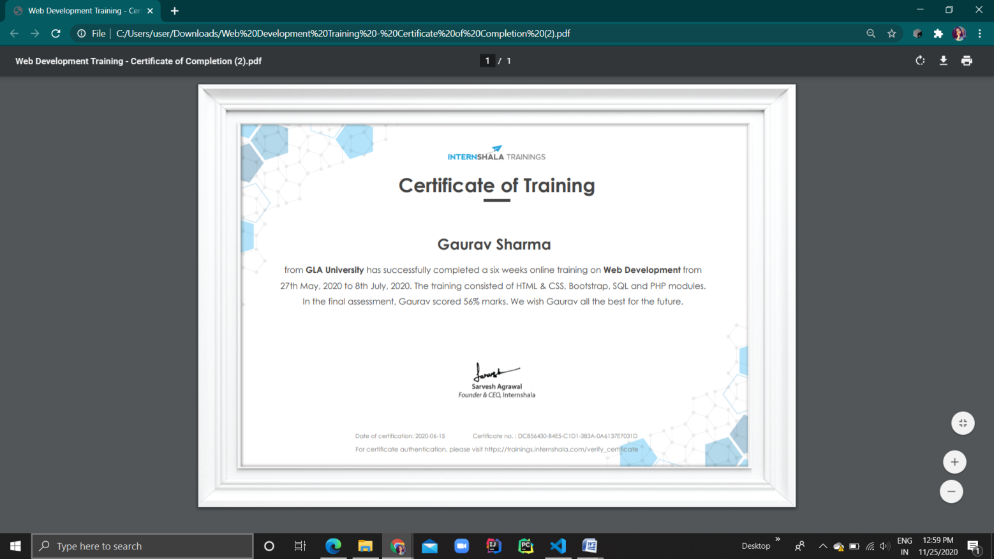

Name of Candidate: VISHAL SINGH

Roll. No.: 181500809

Course: B-tech CSE

Year: III

Semester: 5th

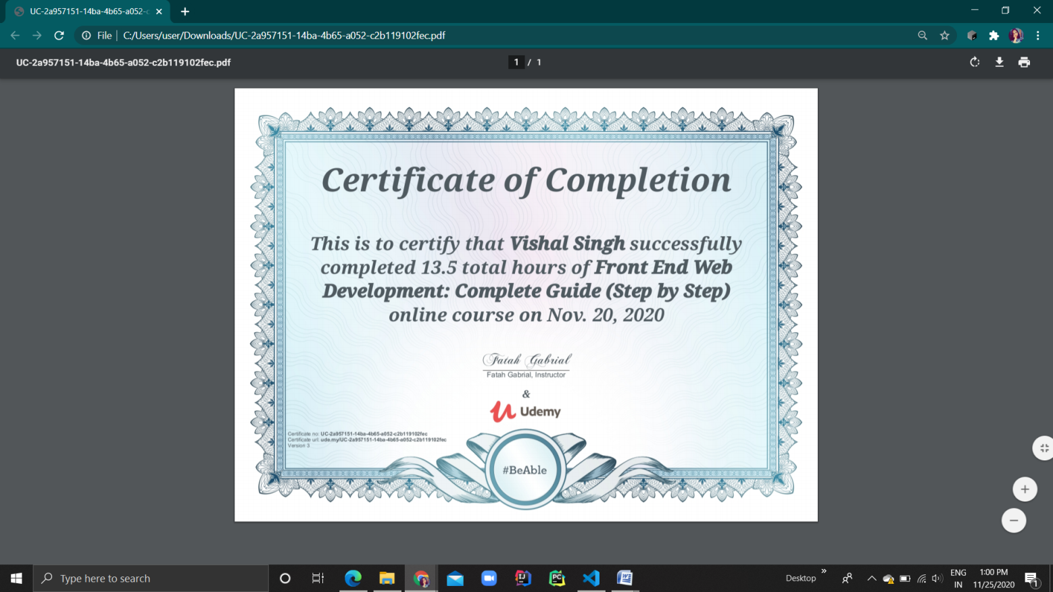

Name of Candidate: MANSI GUPTA

Roll. No.: 181500371

Course: B-tech CSE

Year: III

Semester: 5th

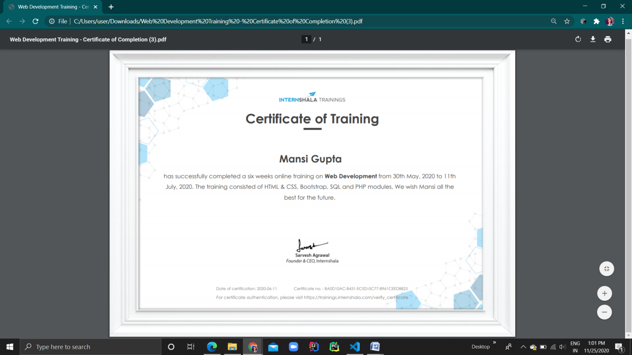

Name of Candidate: HARSH YADAV

Roll. No.: 181500250

Course: B-tech CSE

Year: III

Semester: 5tH

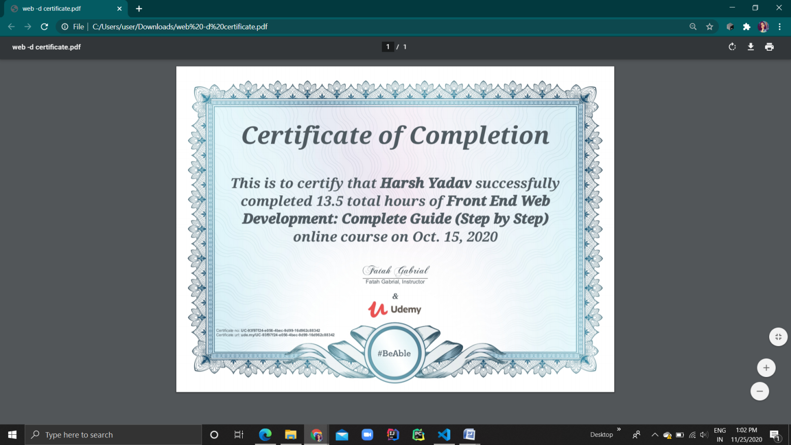

Name of Candidate: PRAKHAR AGRAWAL

Roll. No.: 181500468

Course: B-tech CSE

Year: III

Semester: 5th

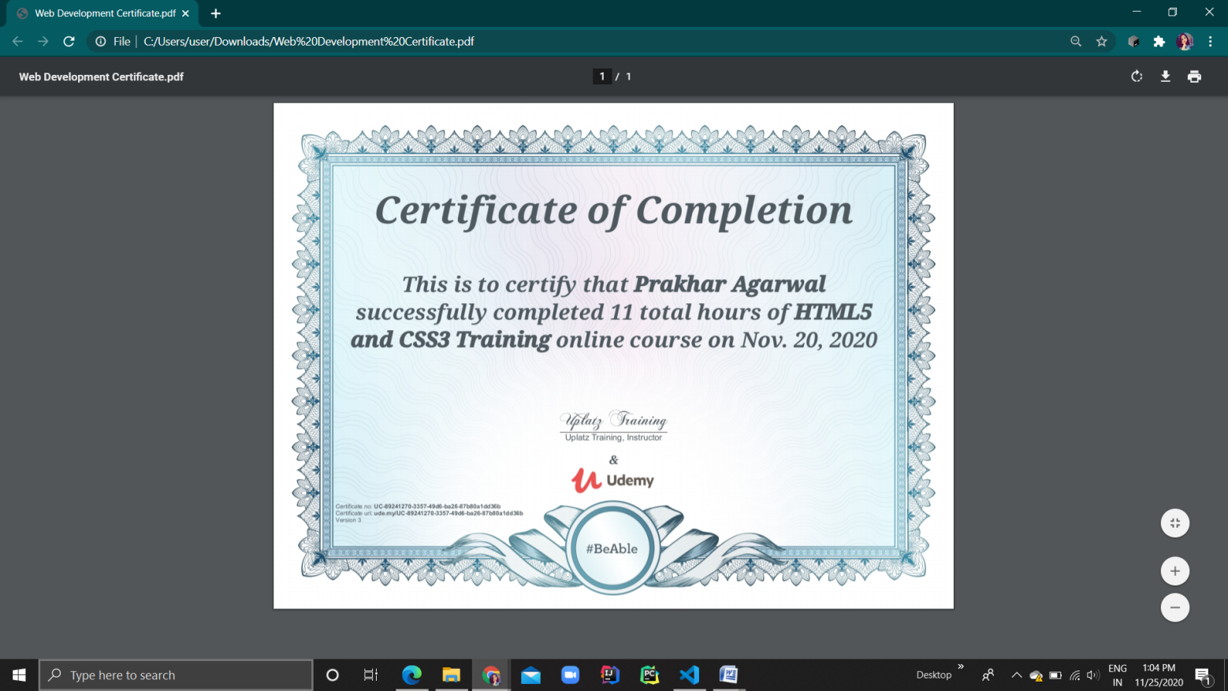

# Progress

# Part 1 is completed.

# Frontend Web Development of JOB BRIDGE

# Create Contact Us page.

# Create Register/Login page.

# Create Image page.

# Create Address page.

# Frontend development work is 100% completed.

# Part 2 is completed.

# Backend Web Development of JOB BRIDGE

# Login form connected.

# Student/Employee form connected.

# Database is connected.

# Query is inserted.

# Backend development work is 100% completed.

# Screenshots

**Index.html**

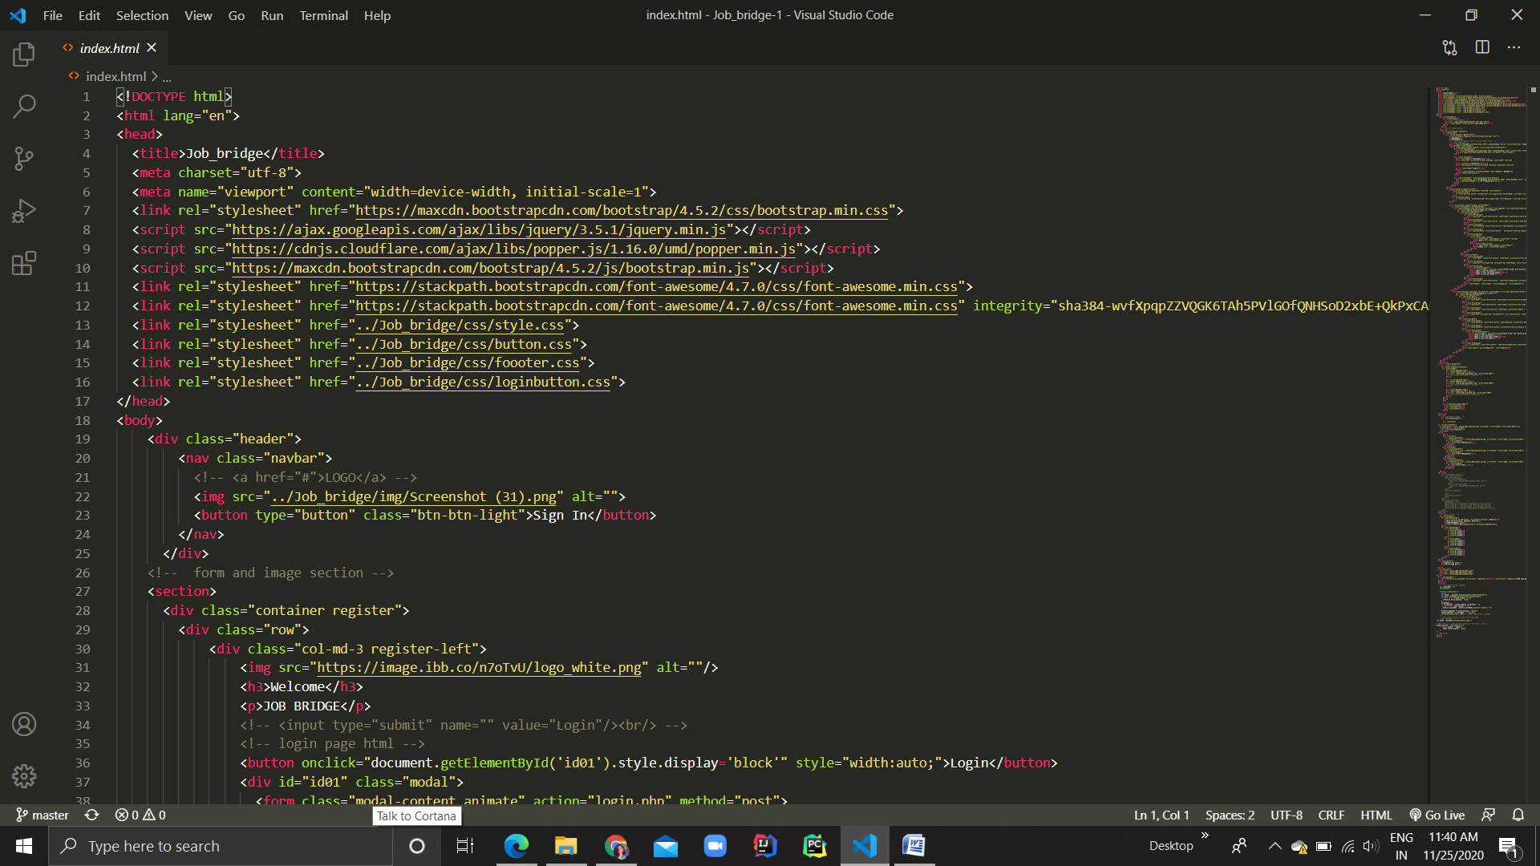

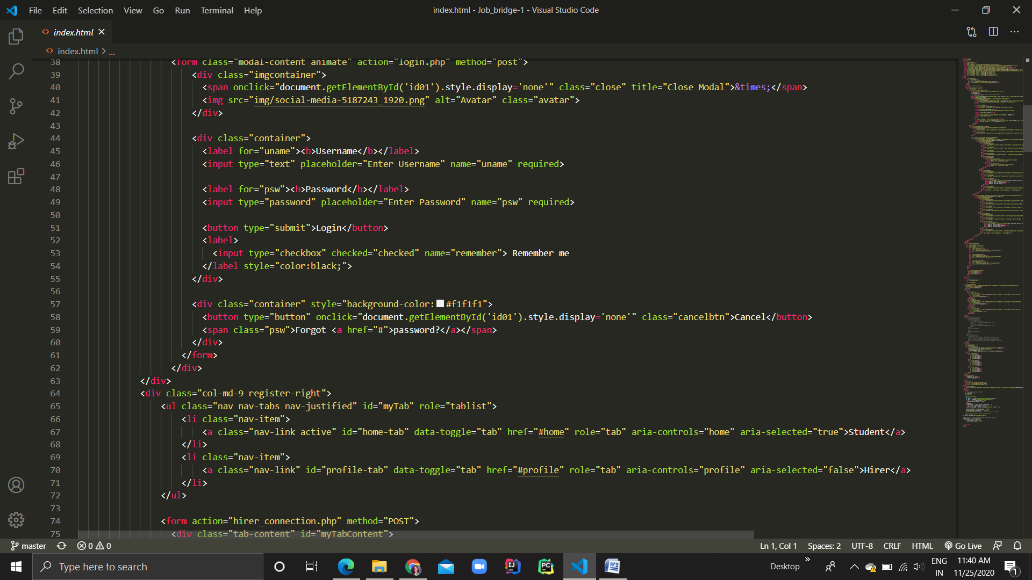

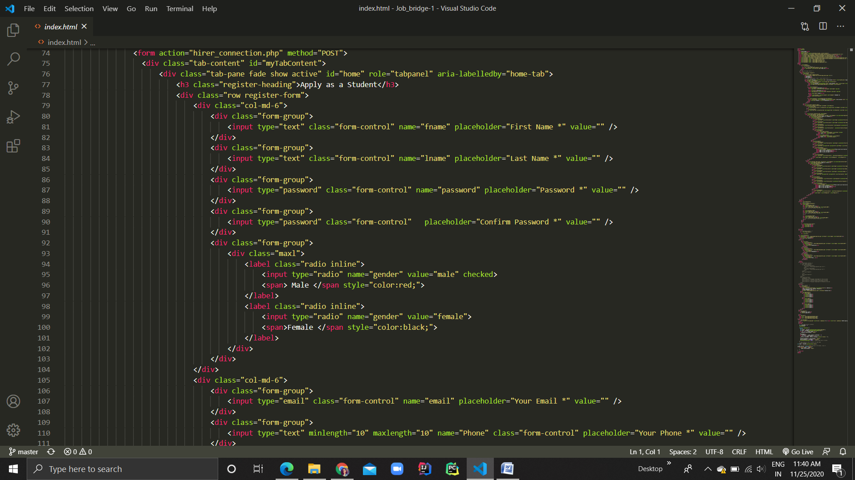

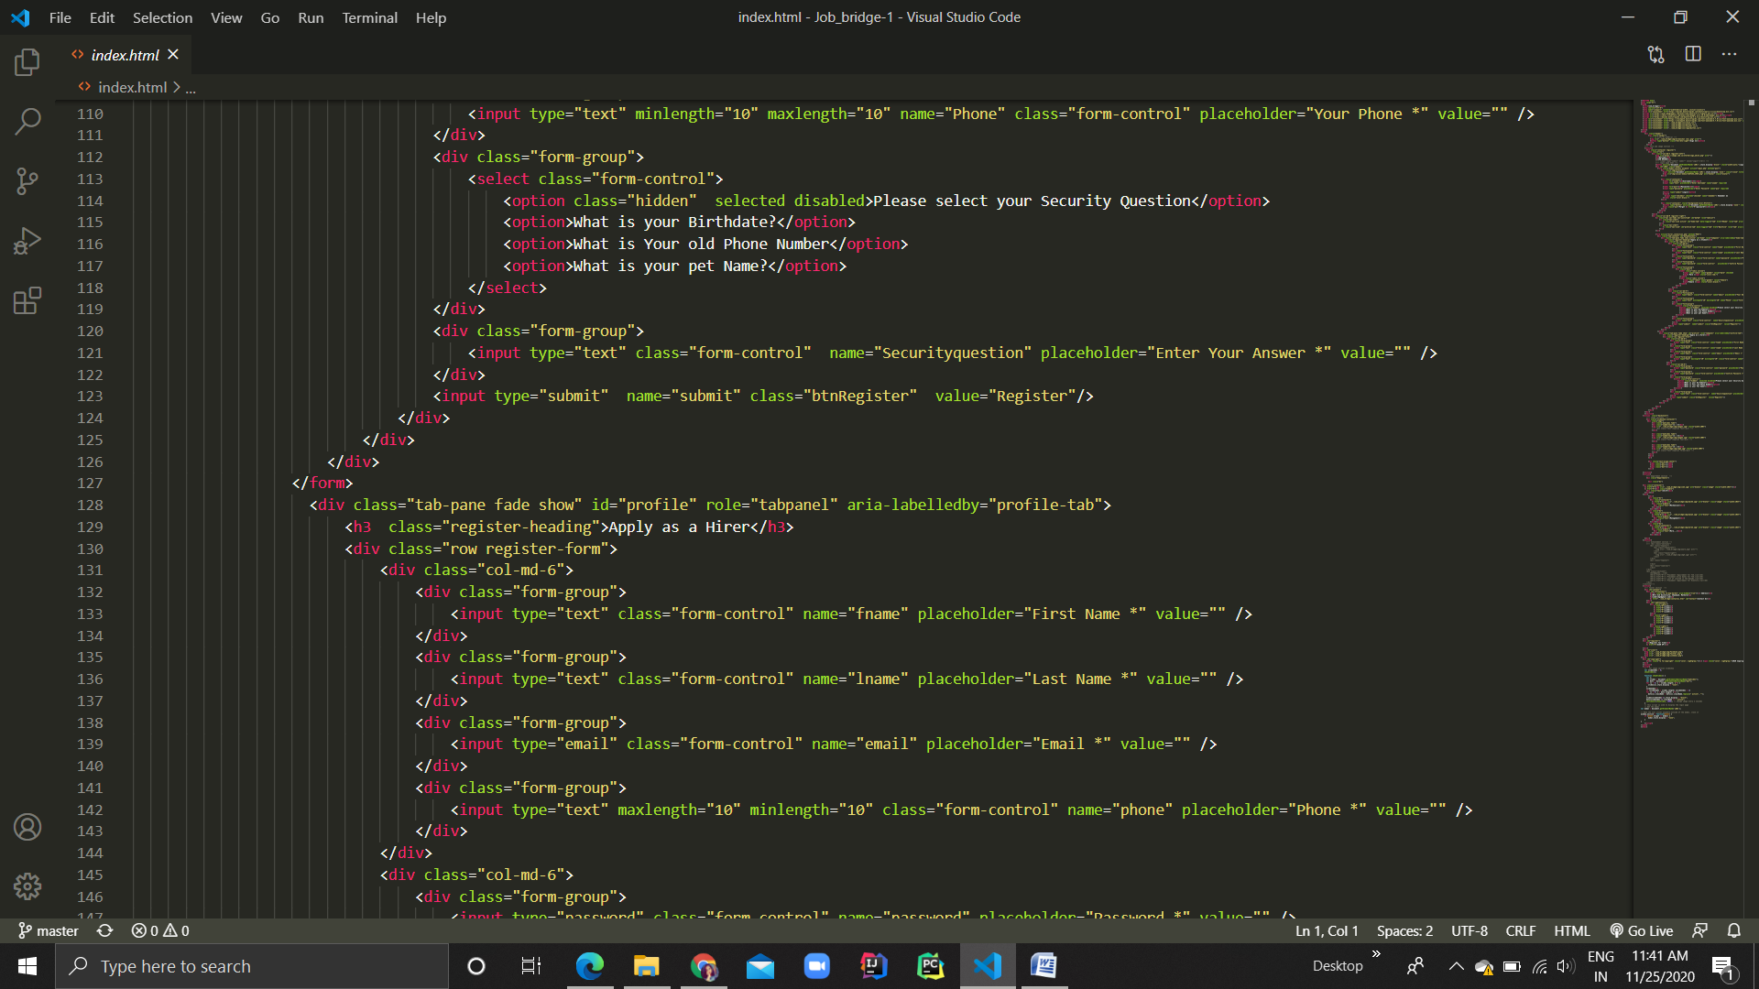

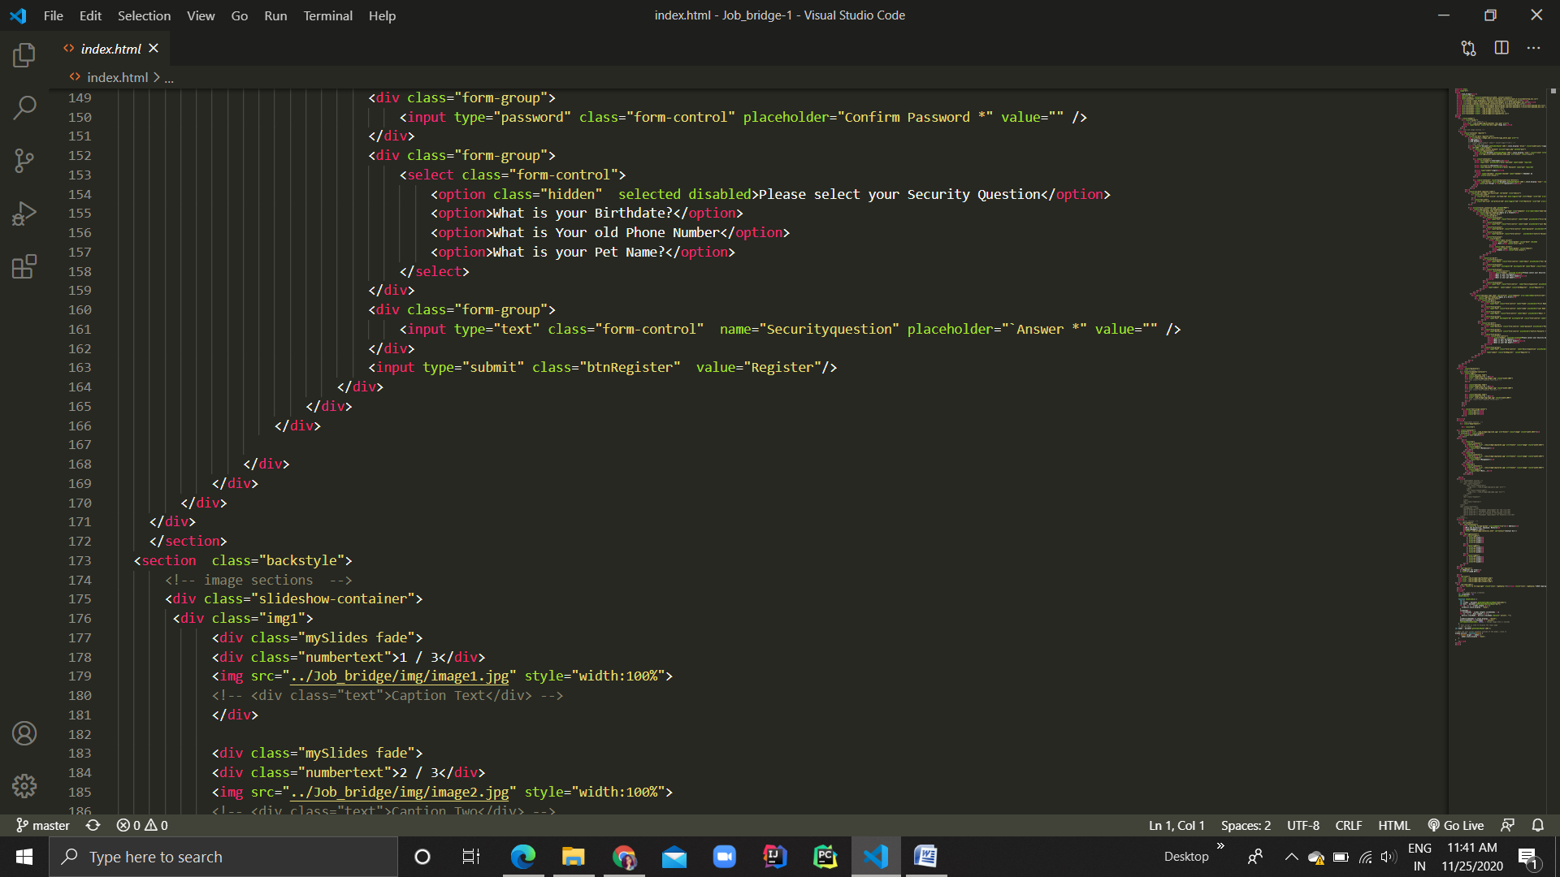

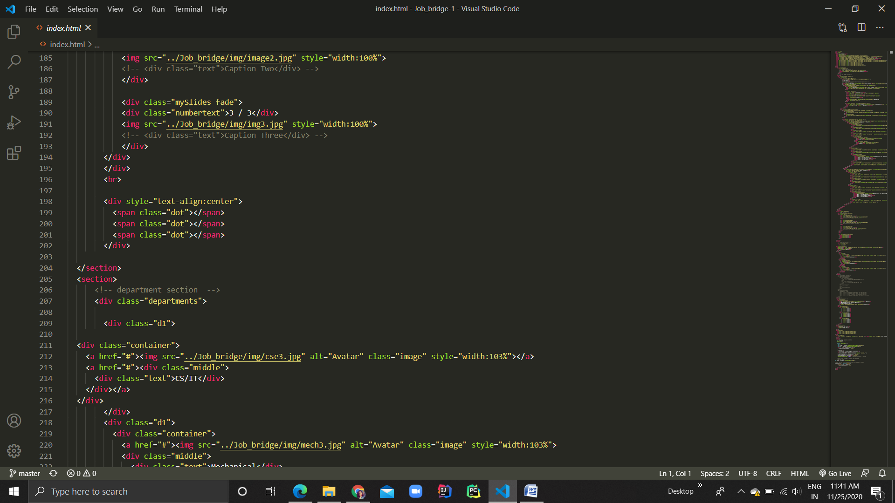

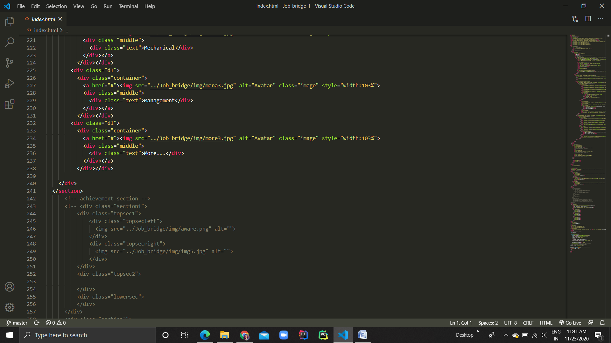

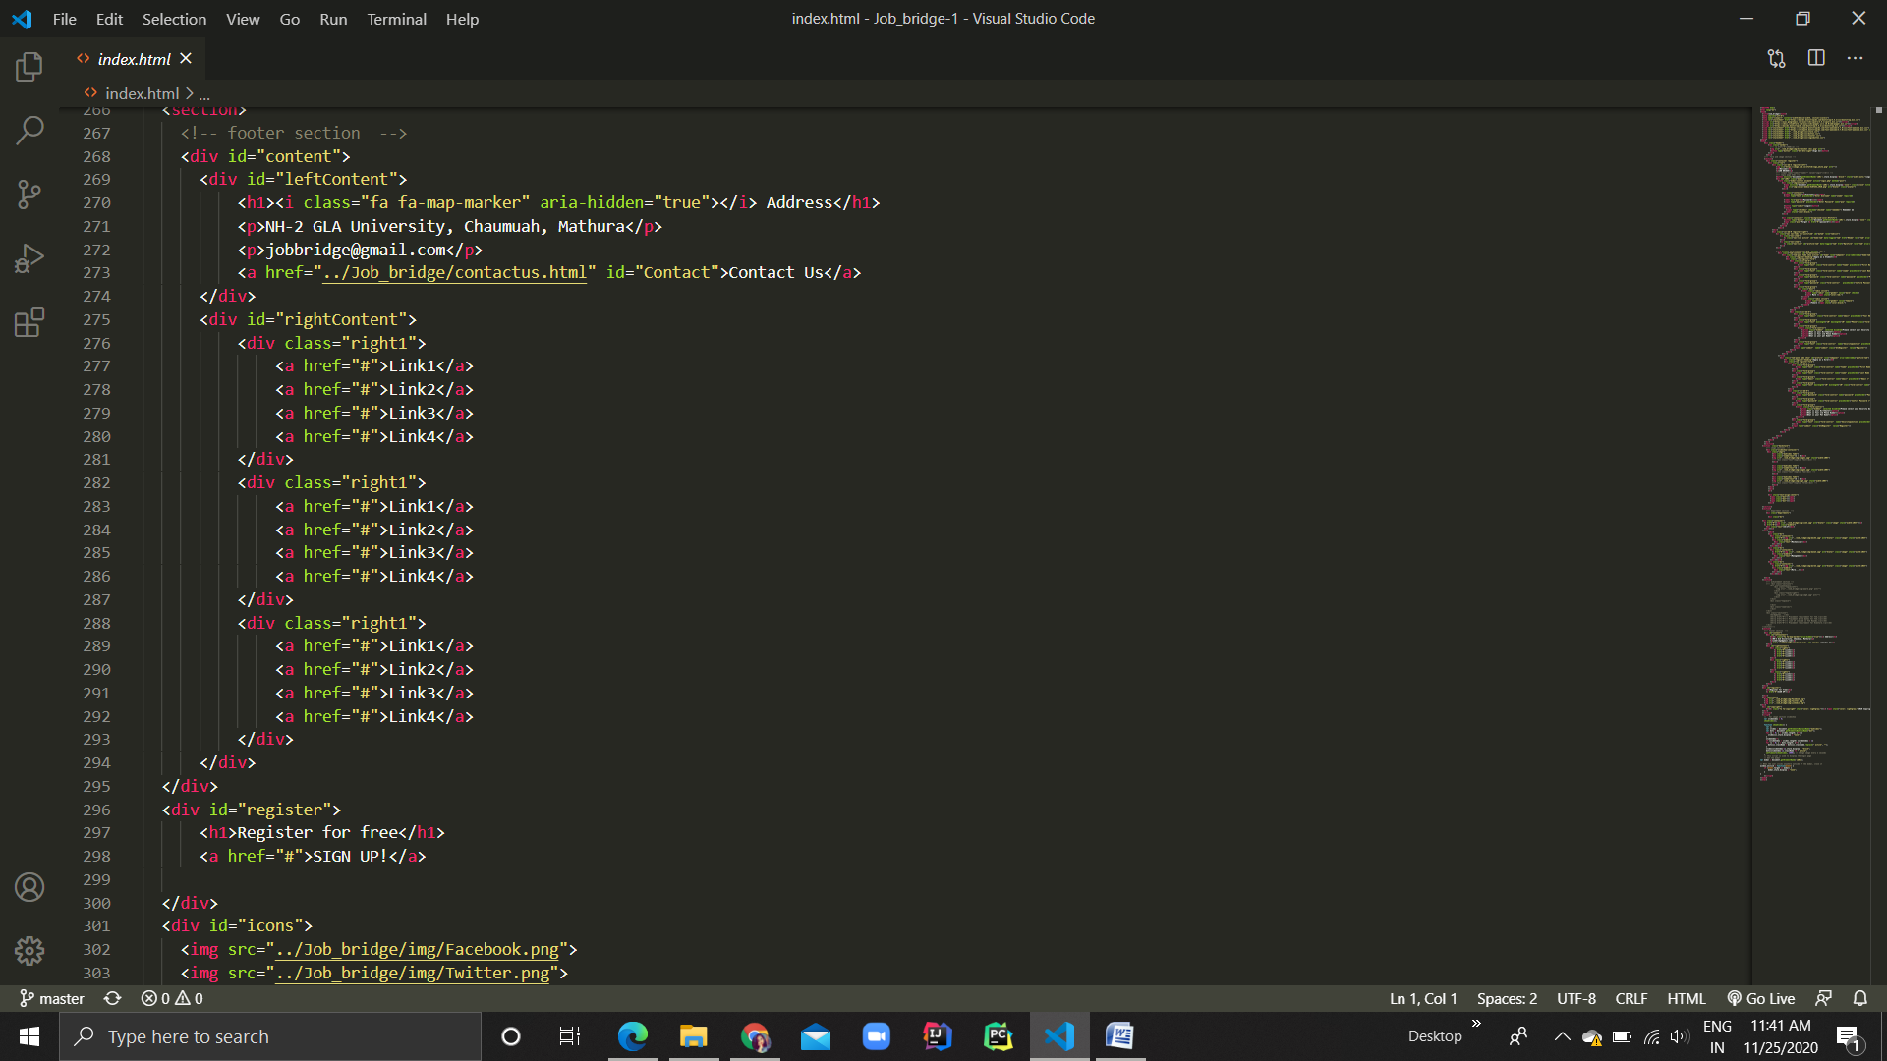

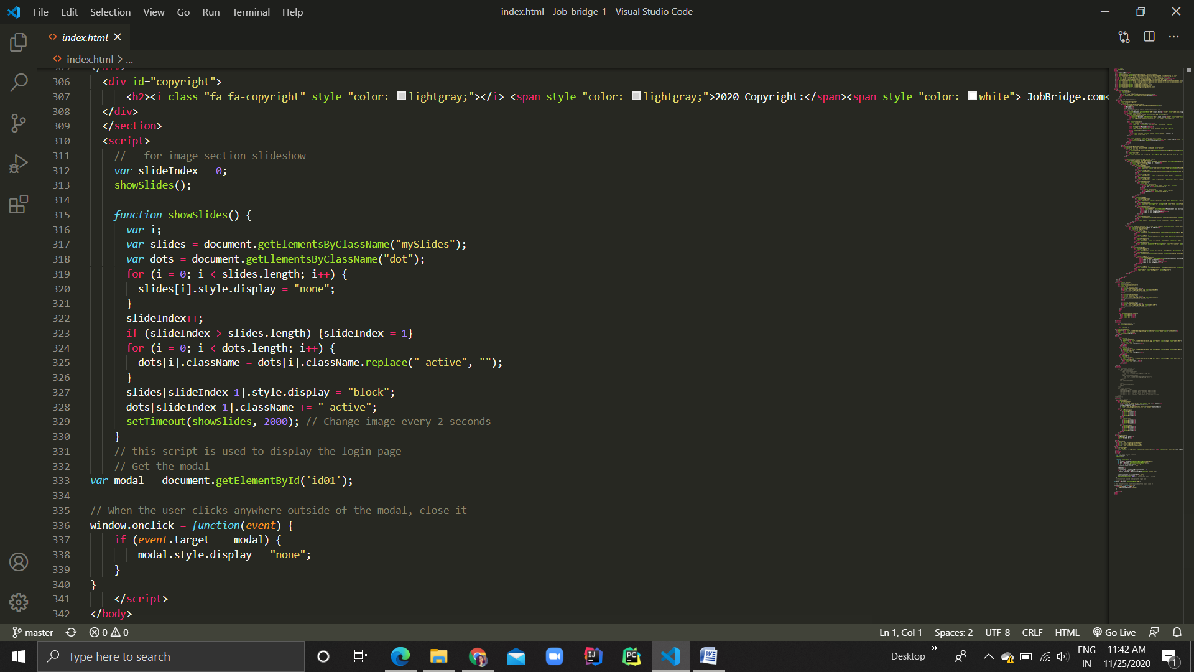

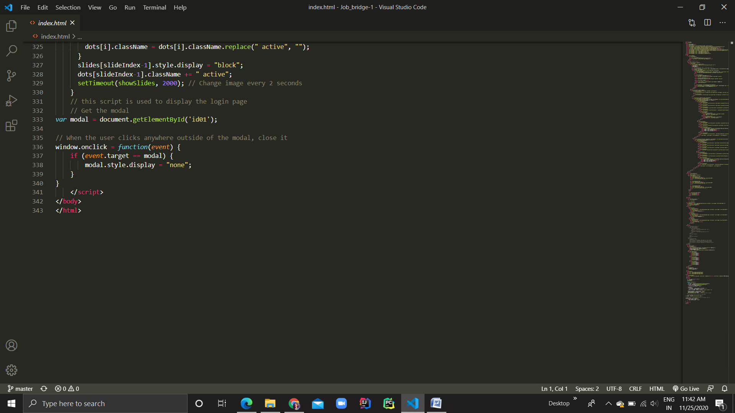

**Index1.html**

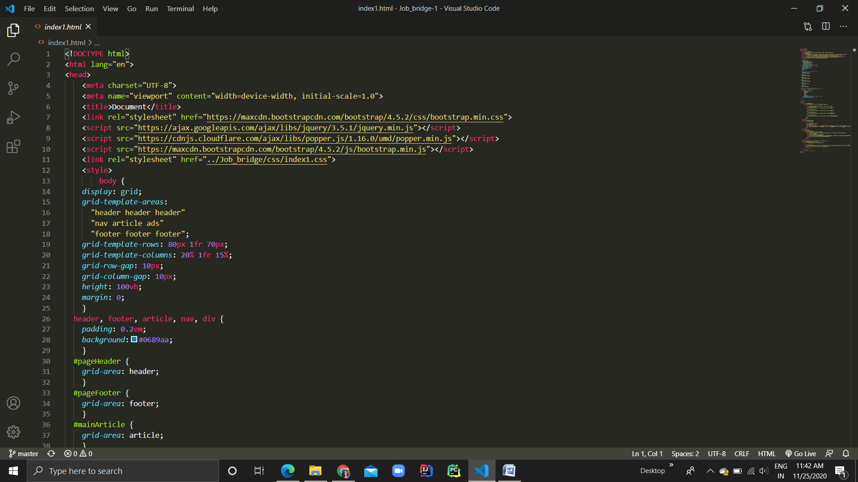

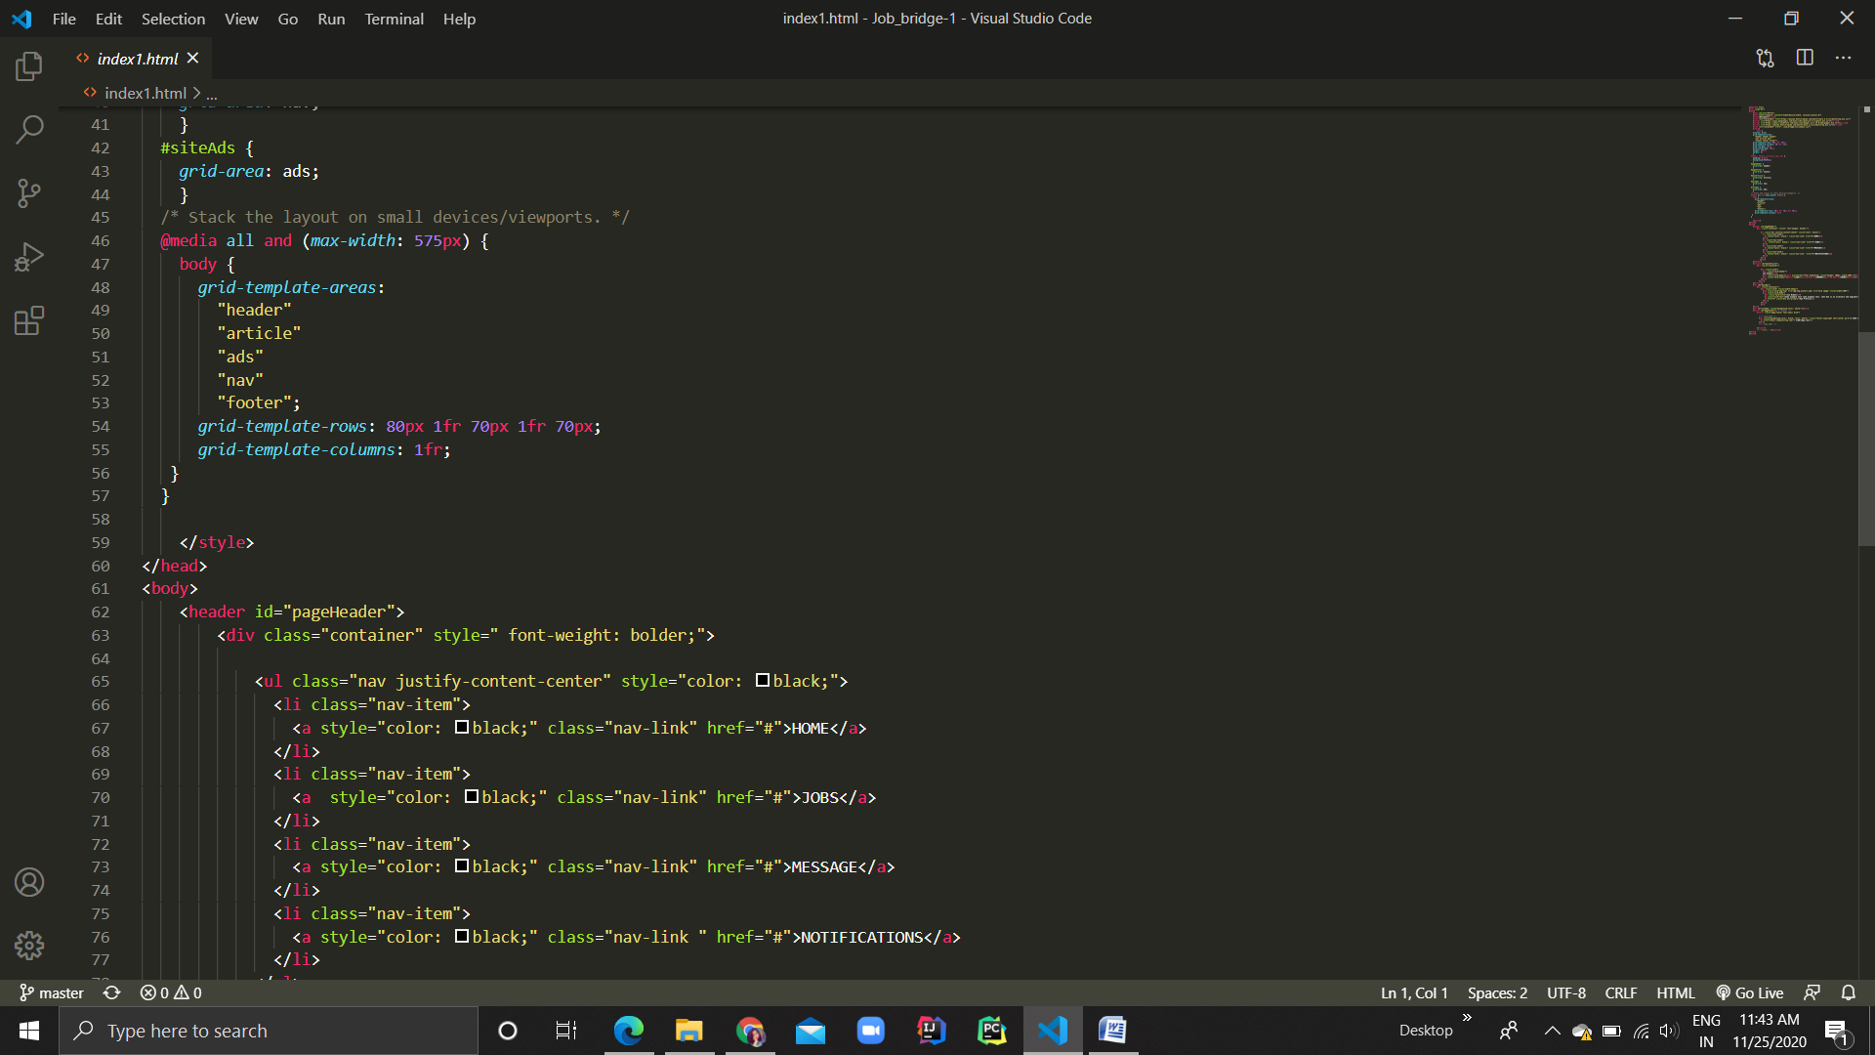

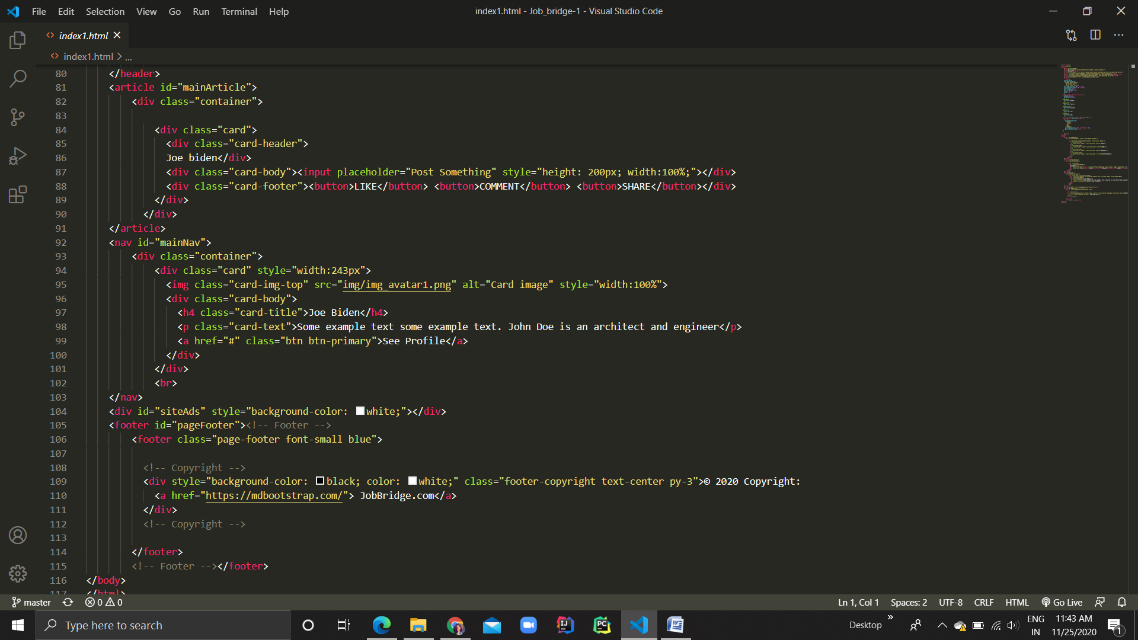

**Login.php**

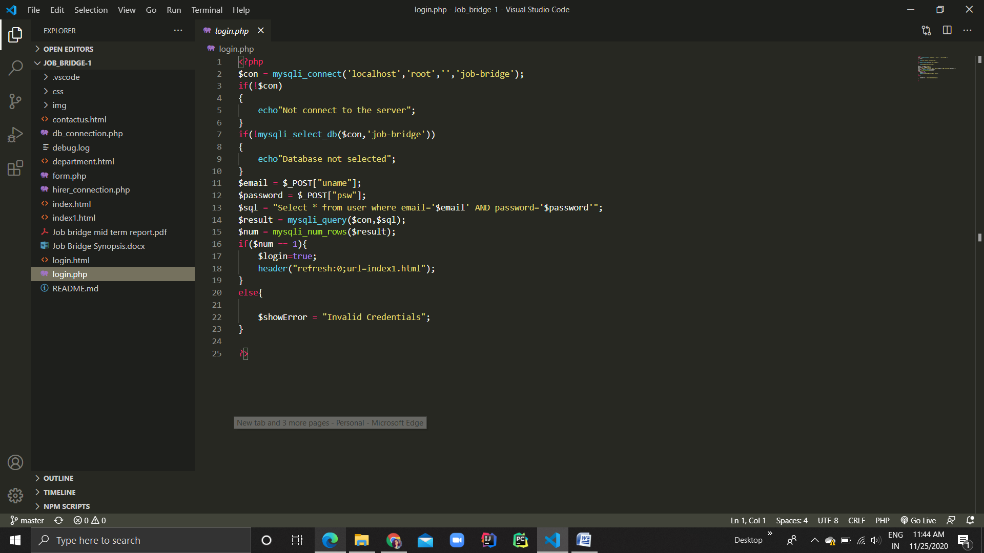

**Hirer_connection.php**

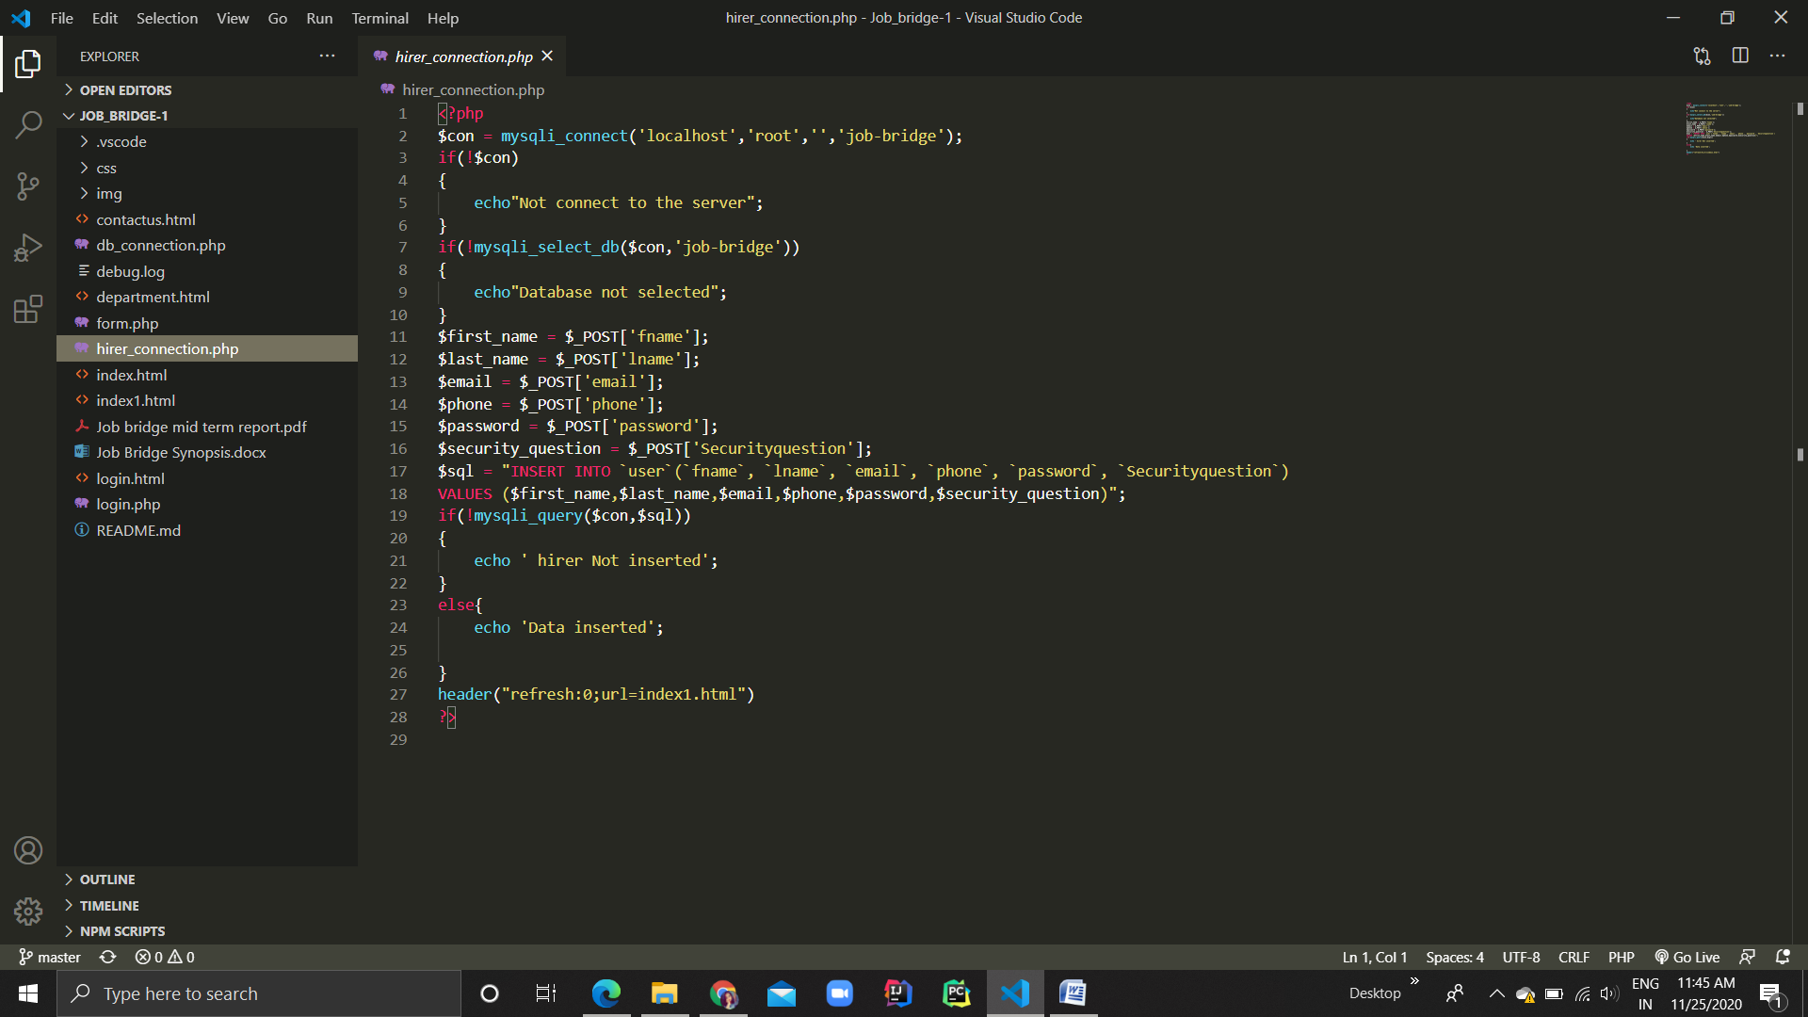

**Form.php**

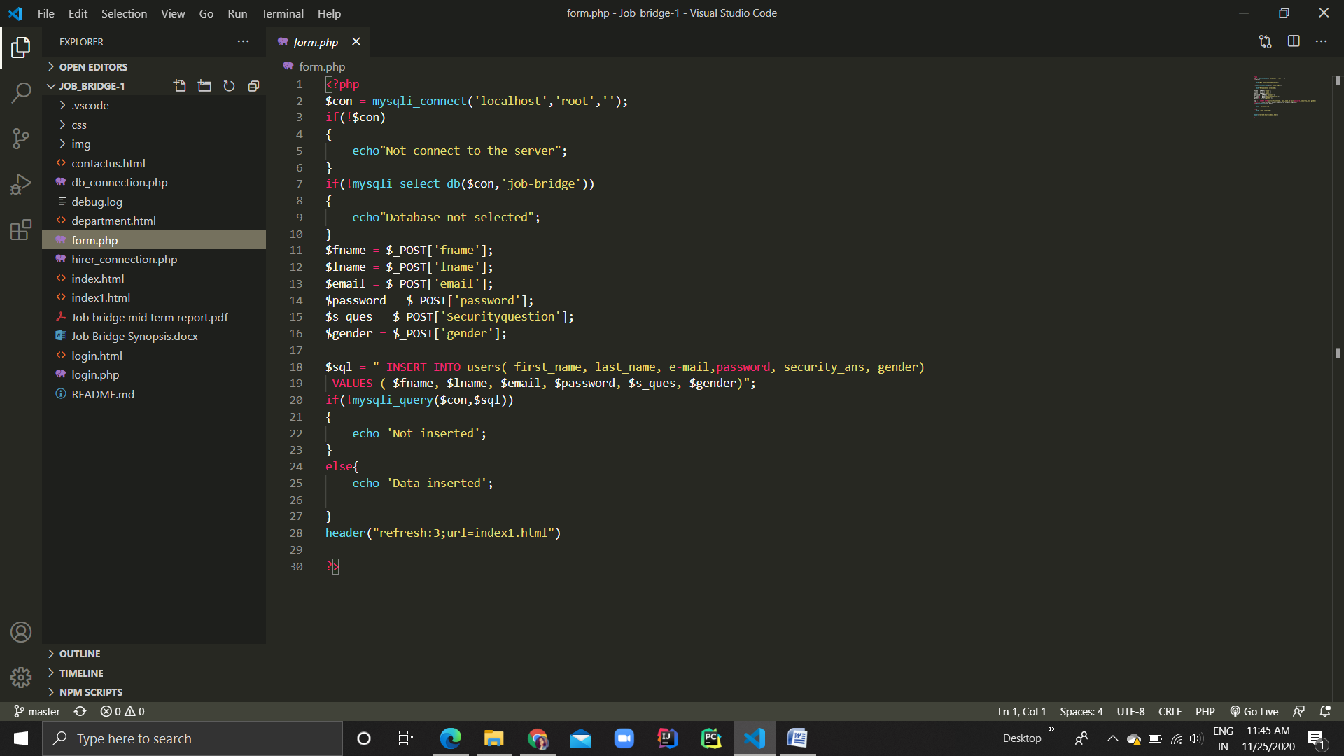

**Department.html**

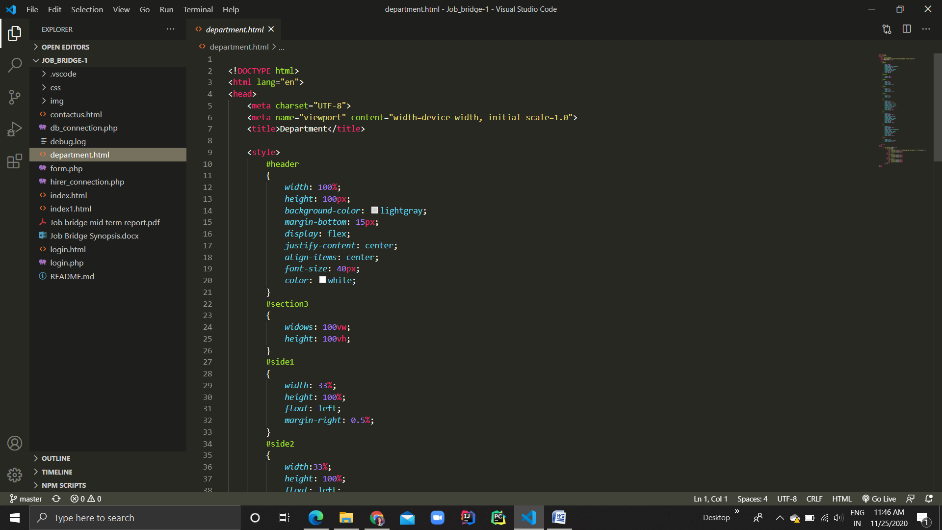

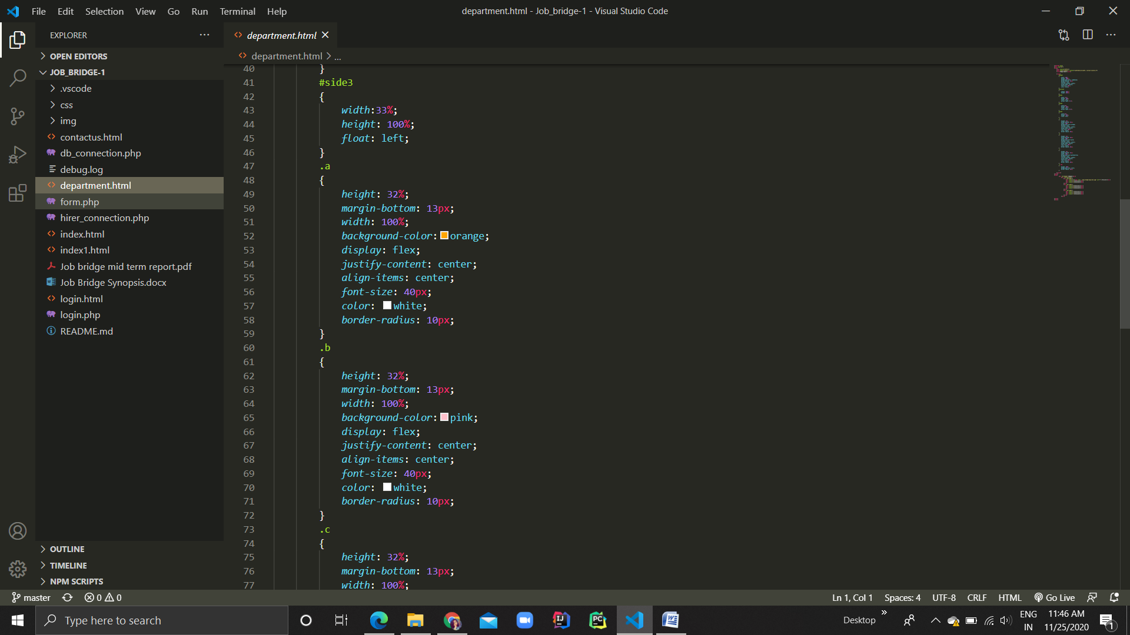

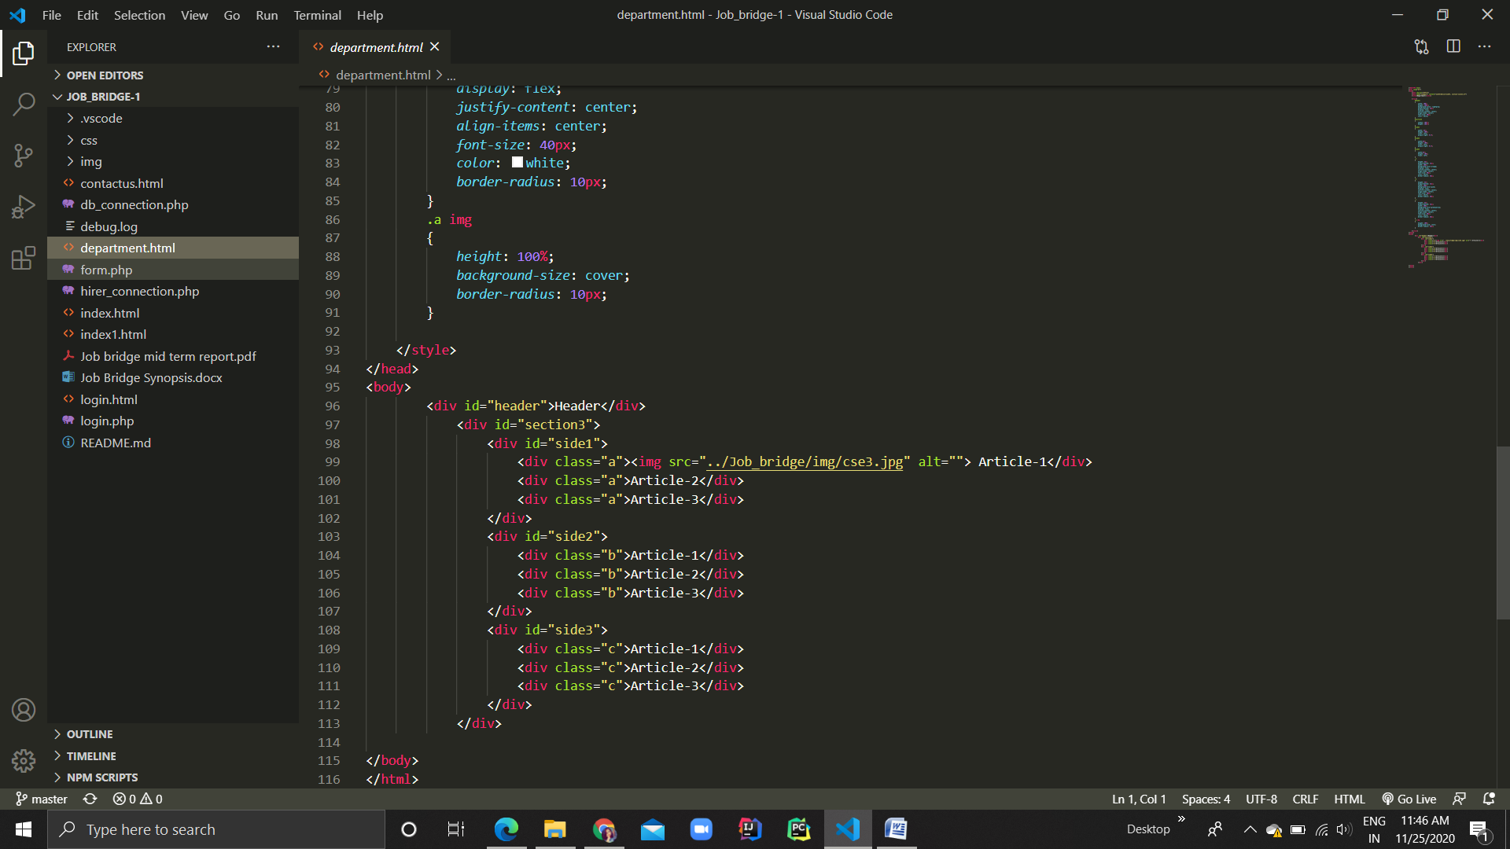

**Contactus.html**

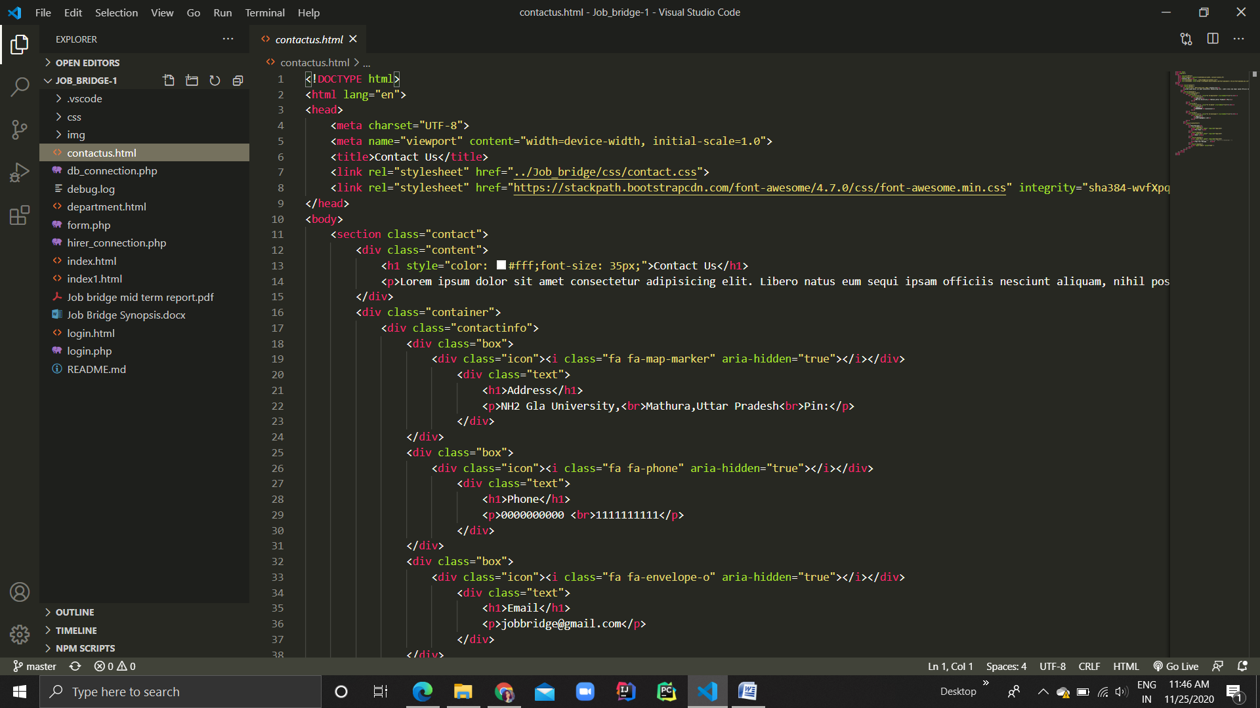

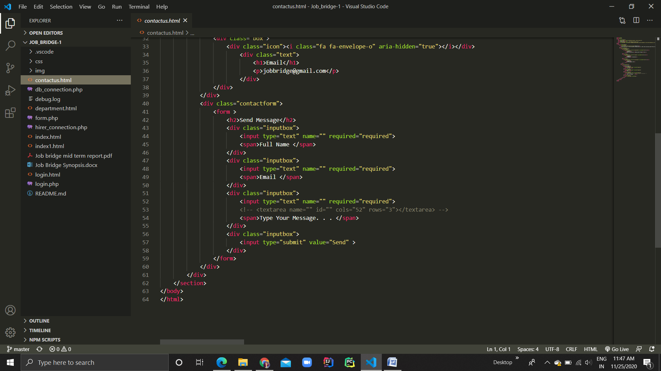

**Button.css**

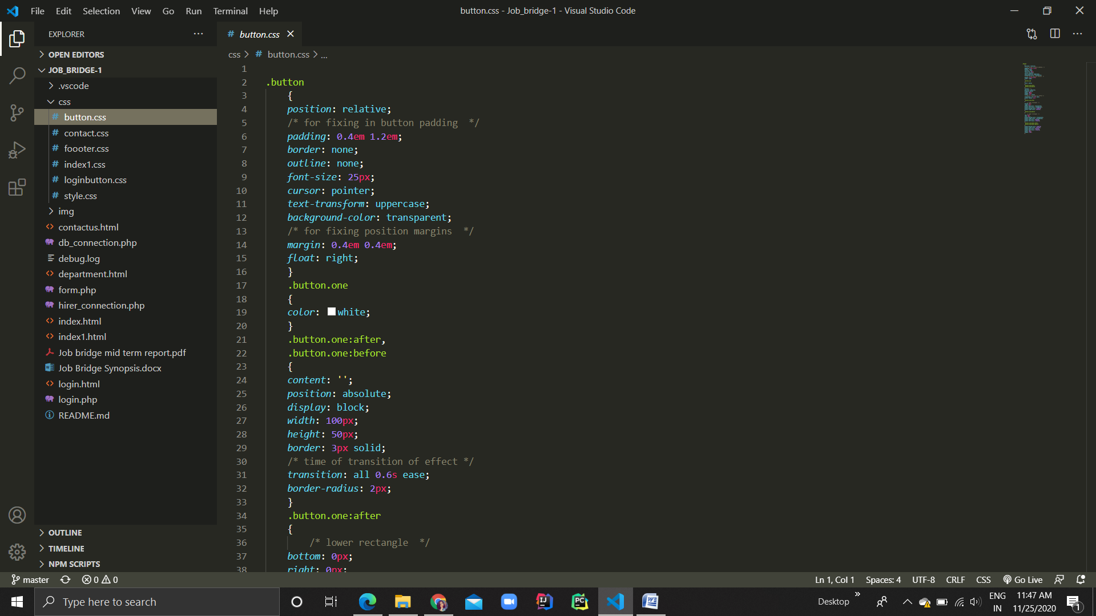

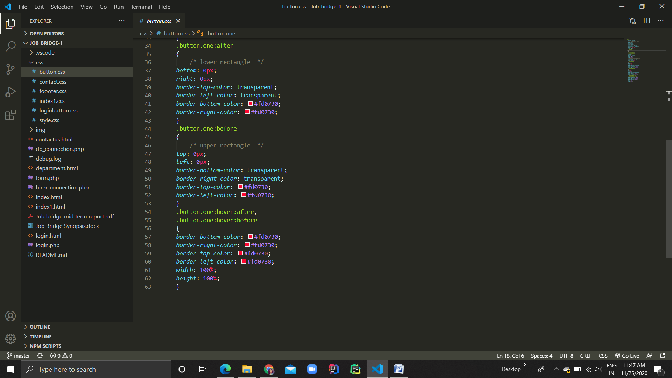

**Contact.css**

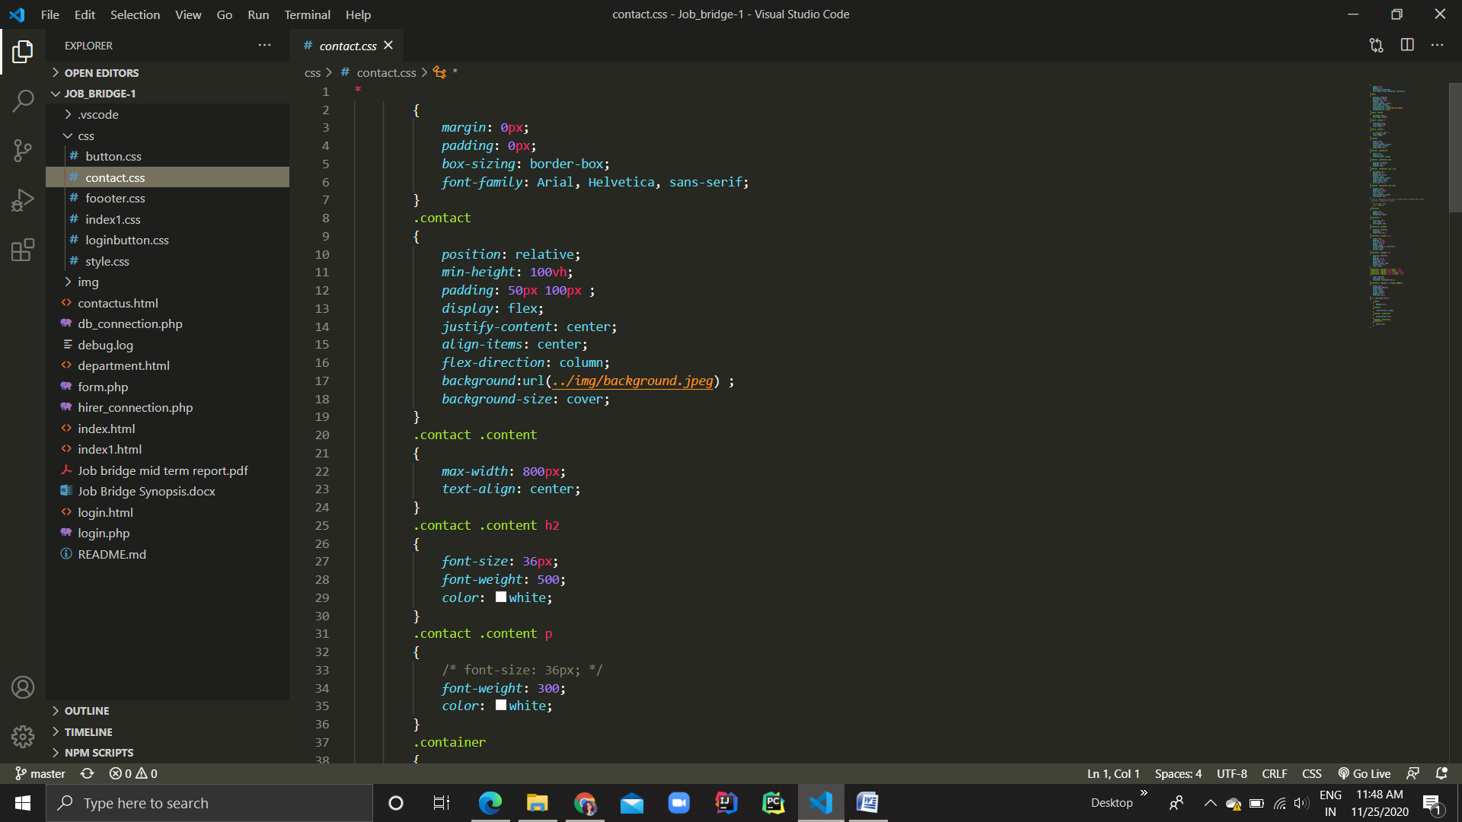

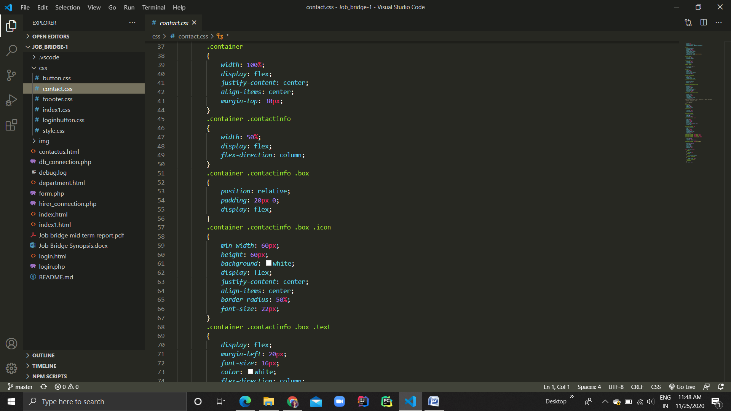

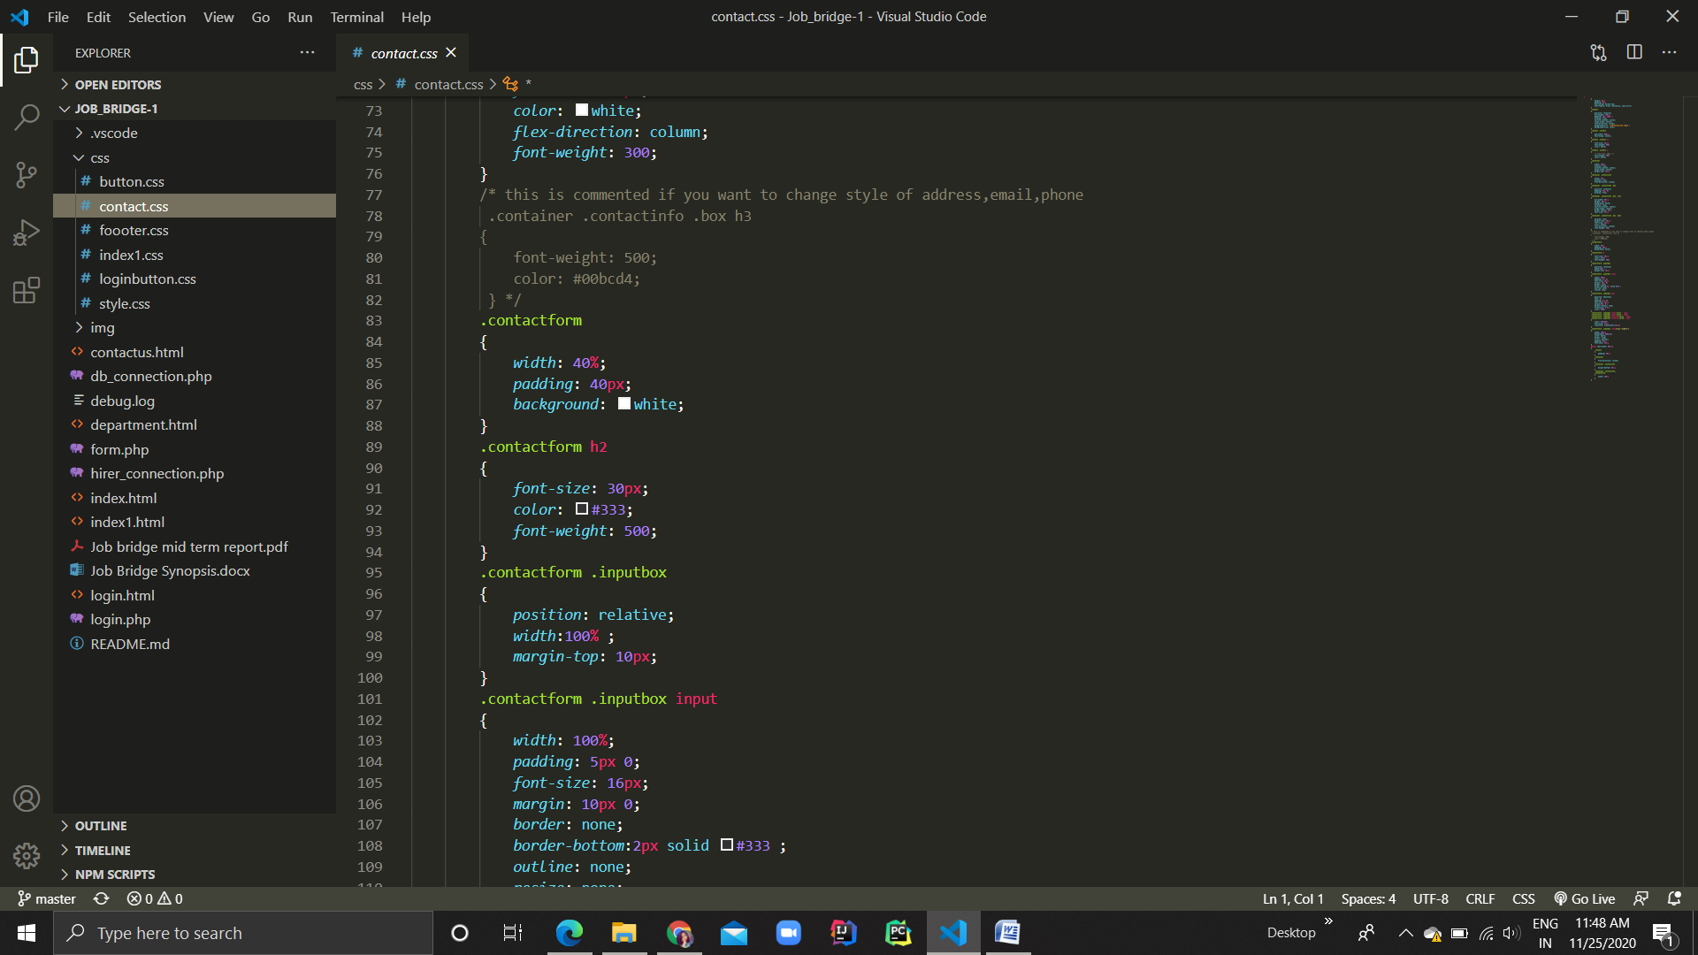

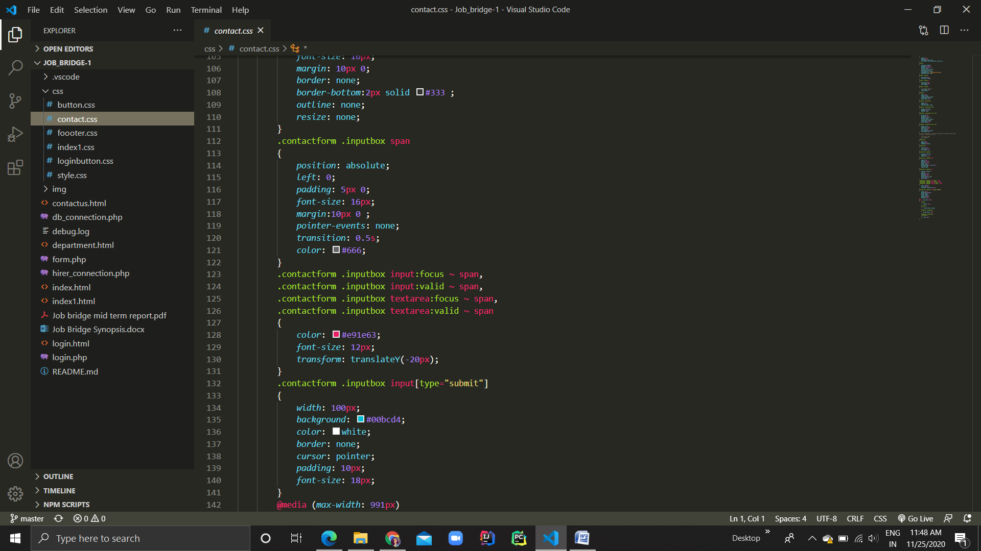

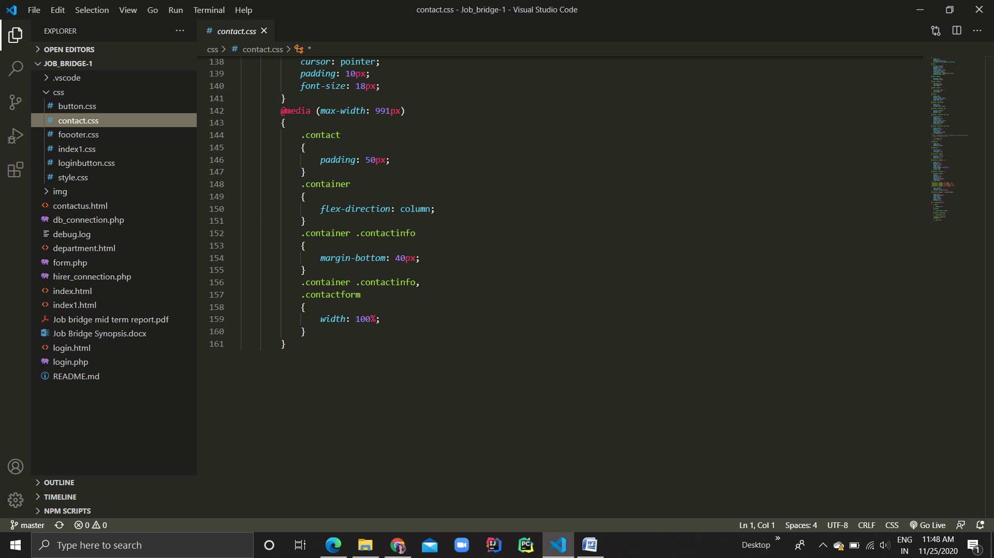

**Footer.css**

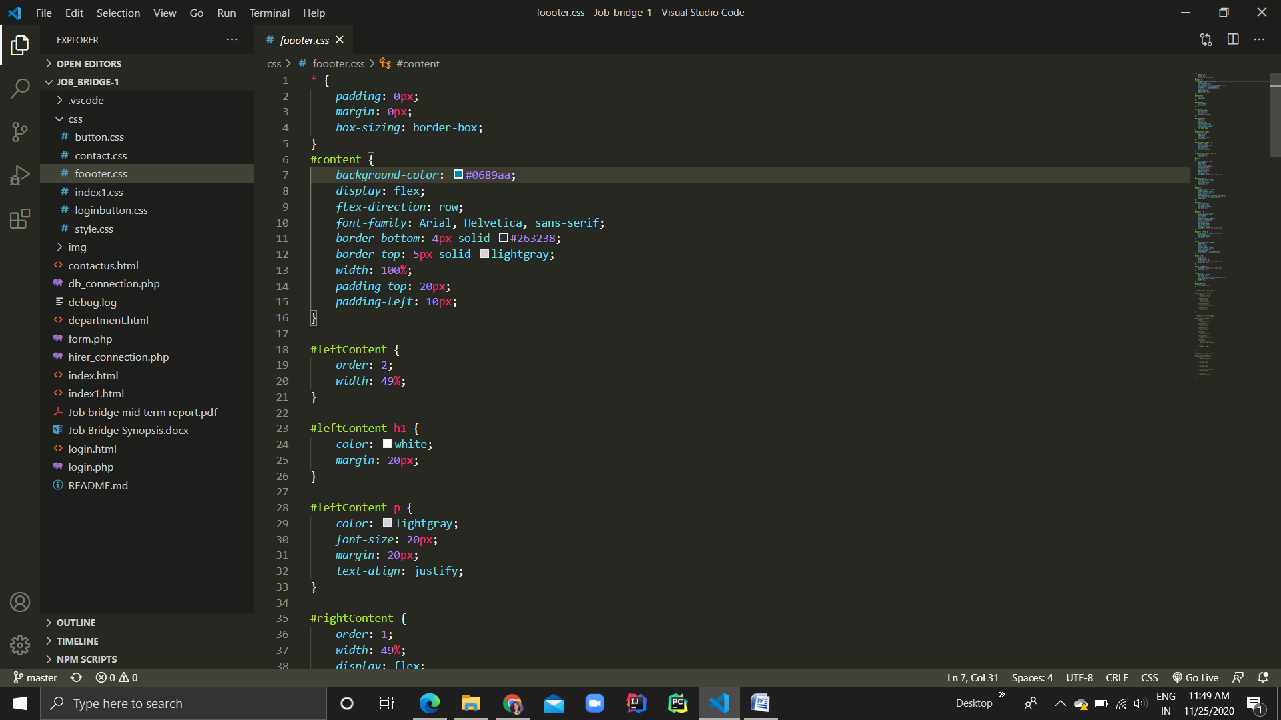

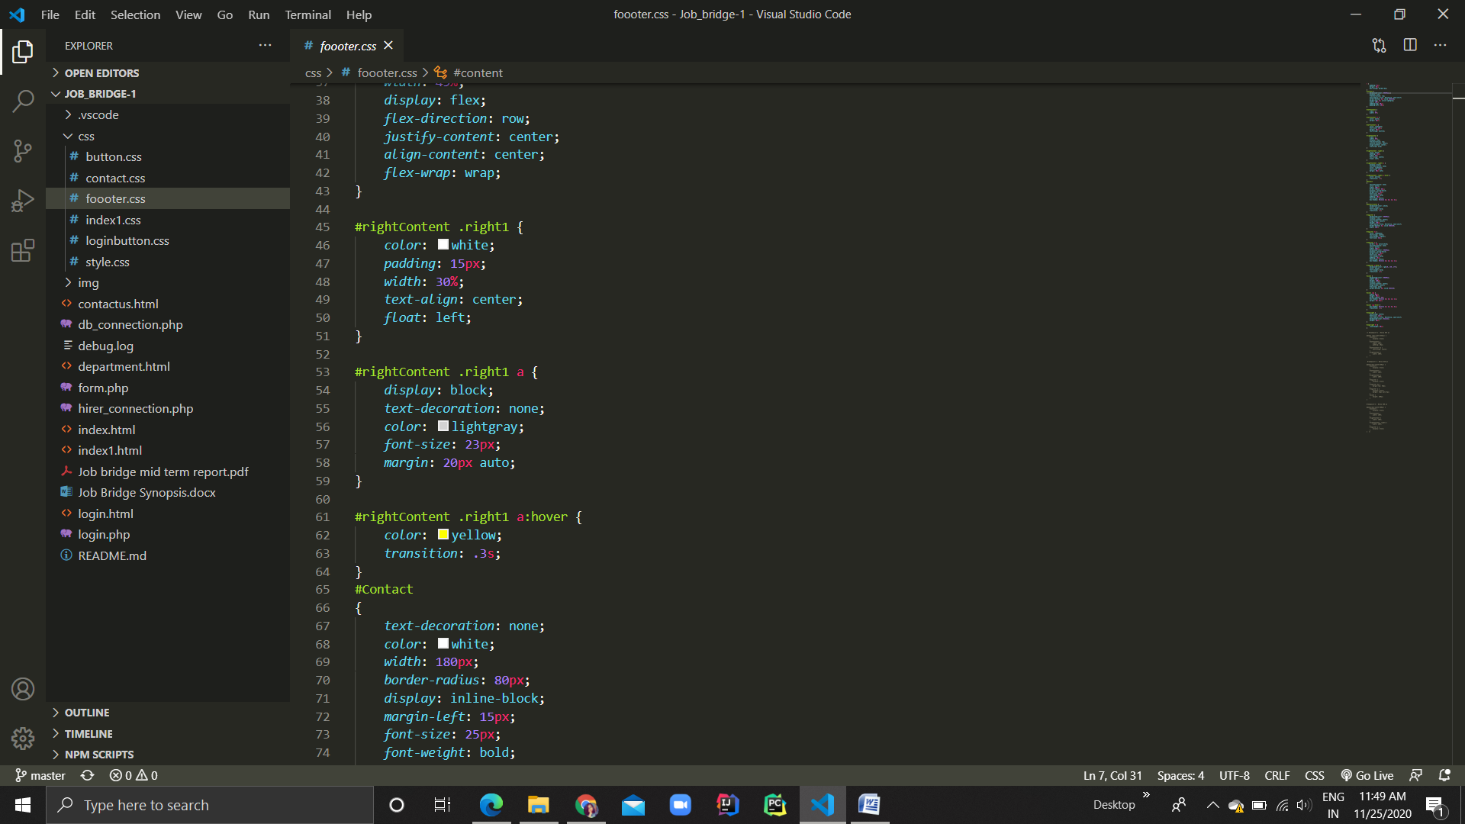

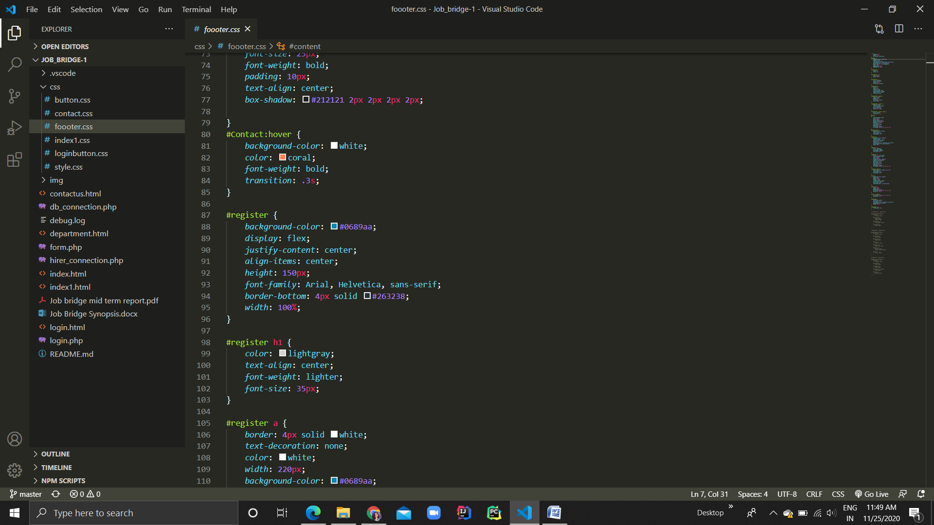

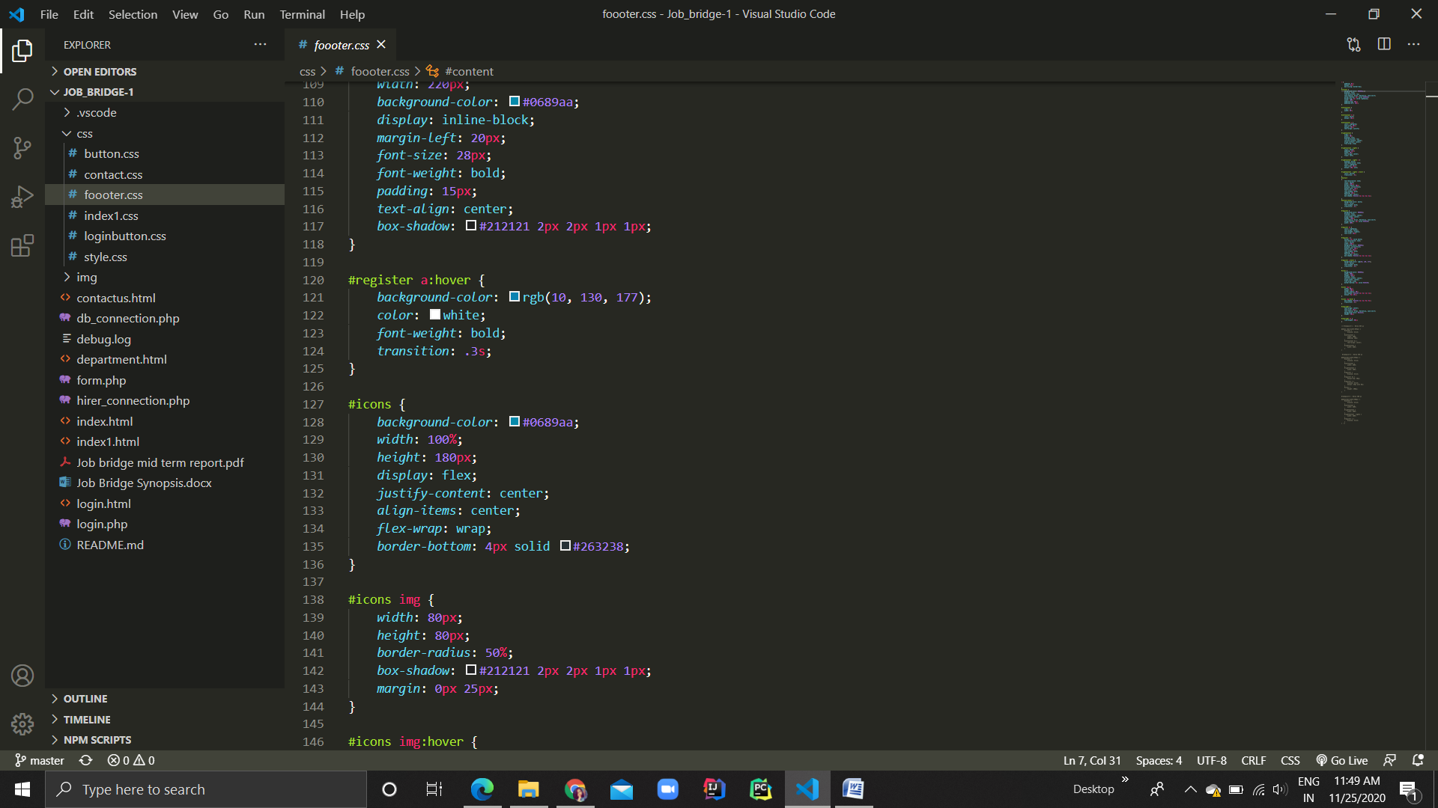

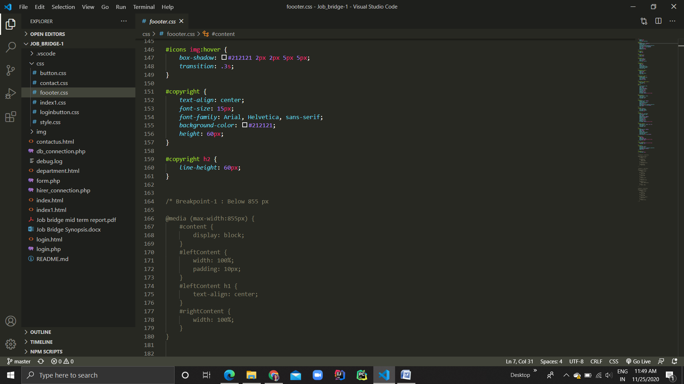

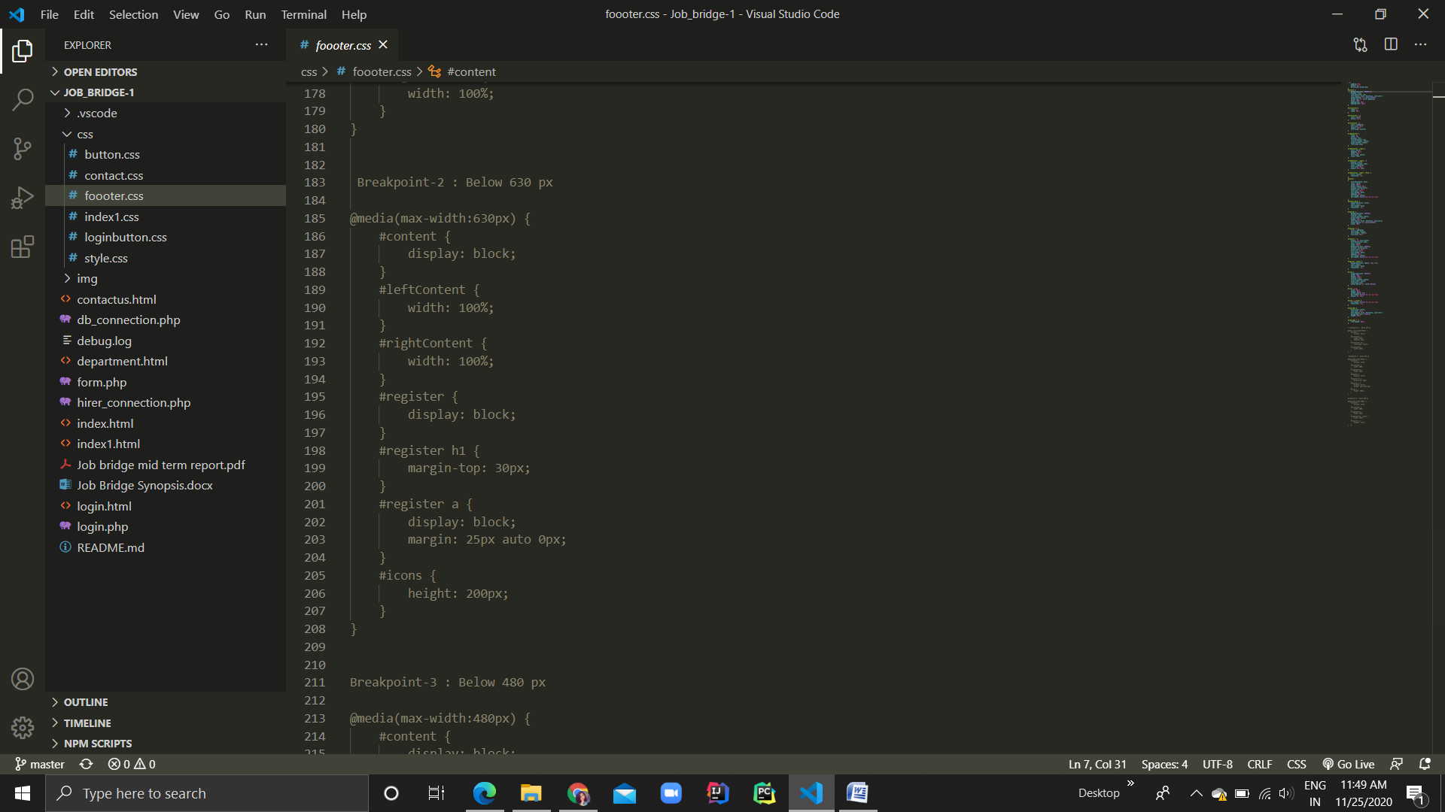

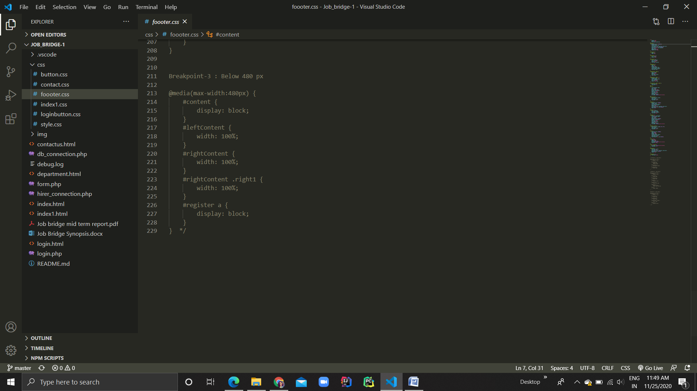

**Index1.css**

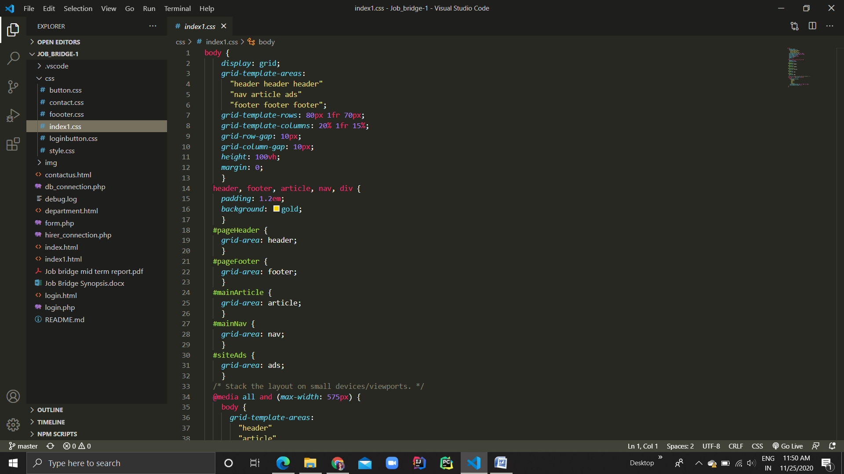

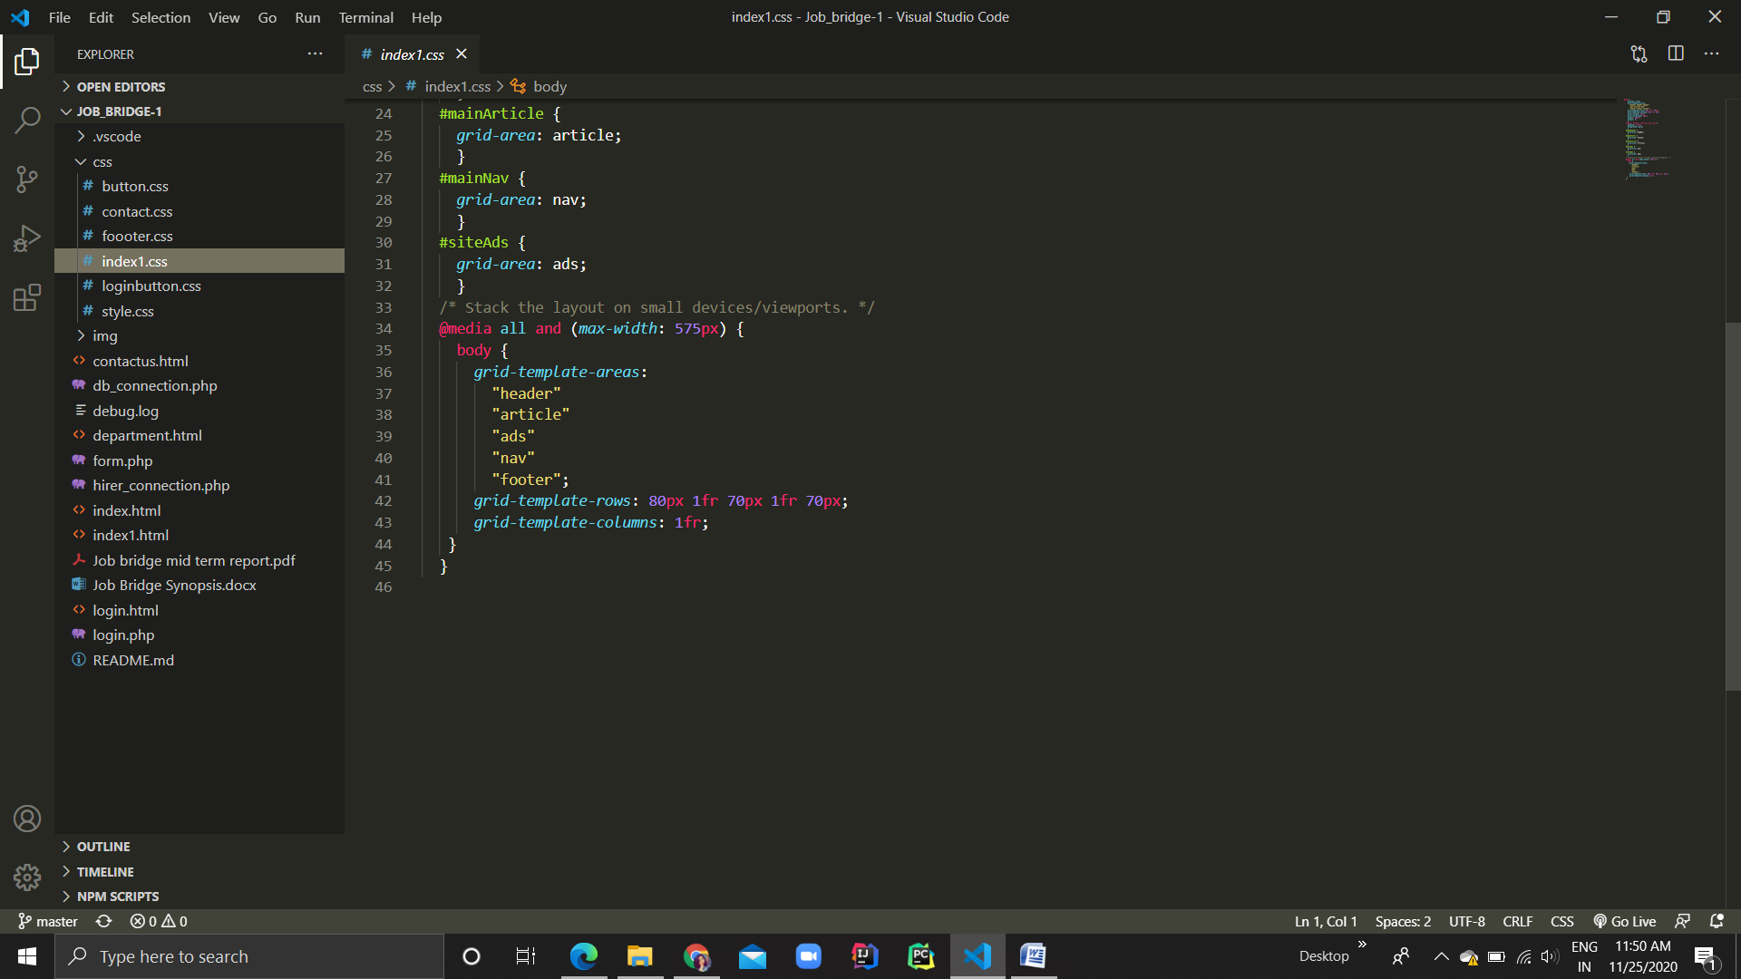

**Loginbutton.css**

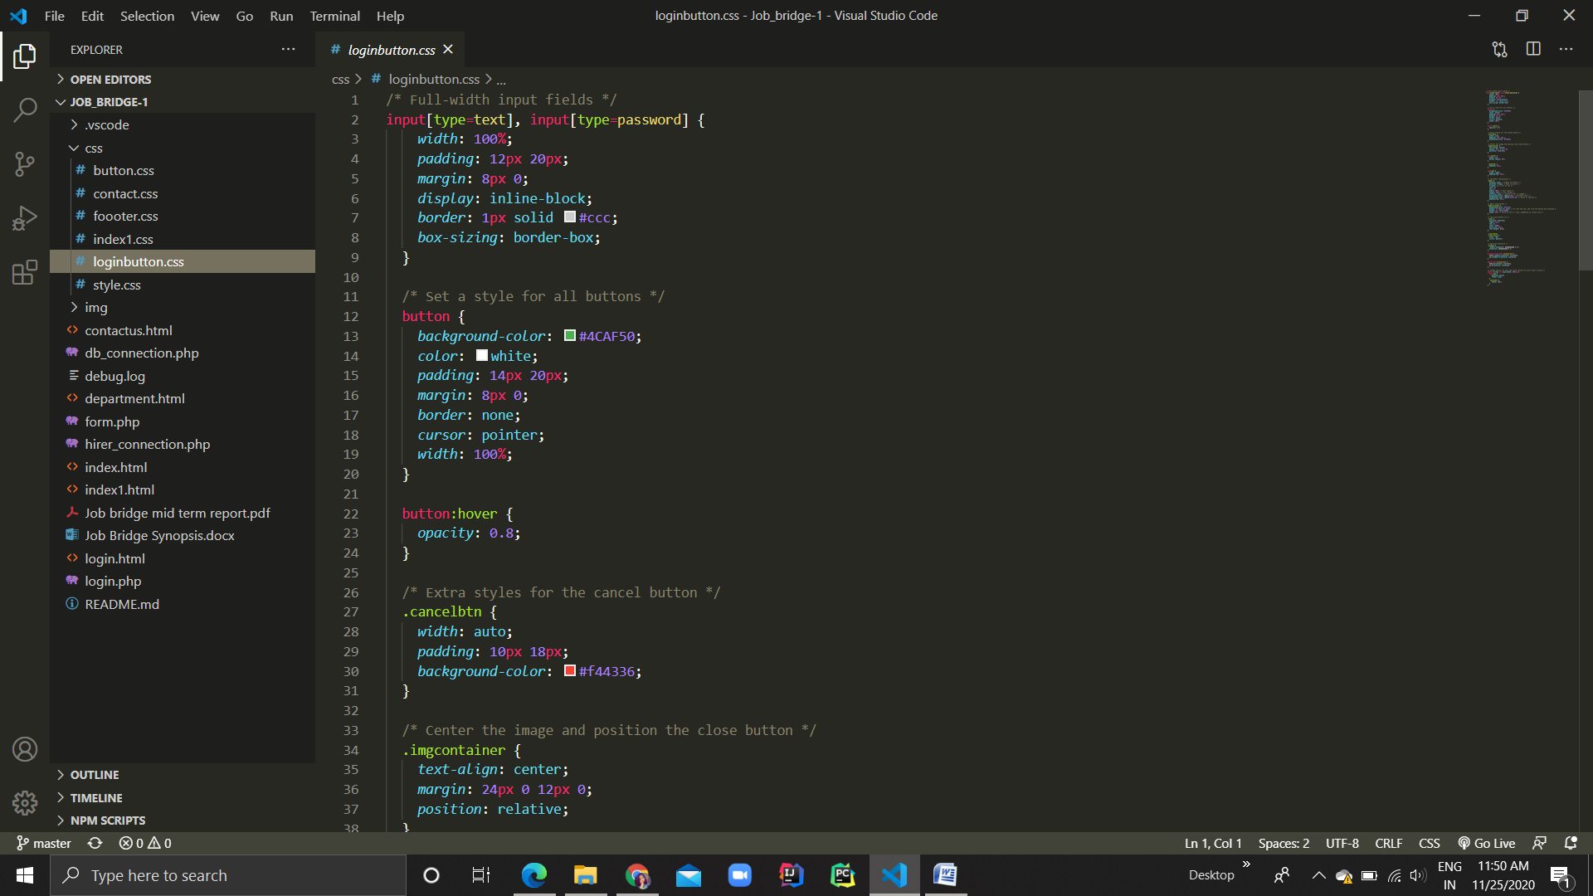

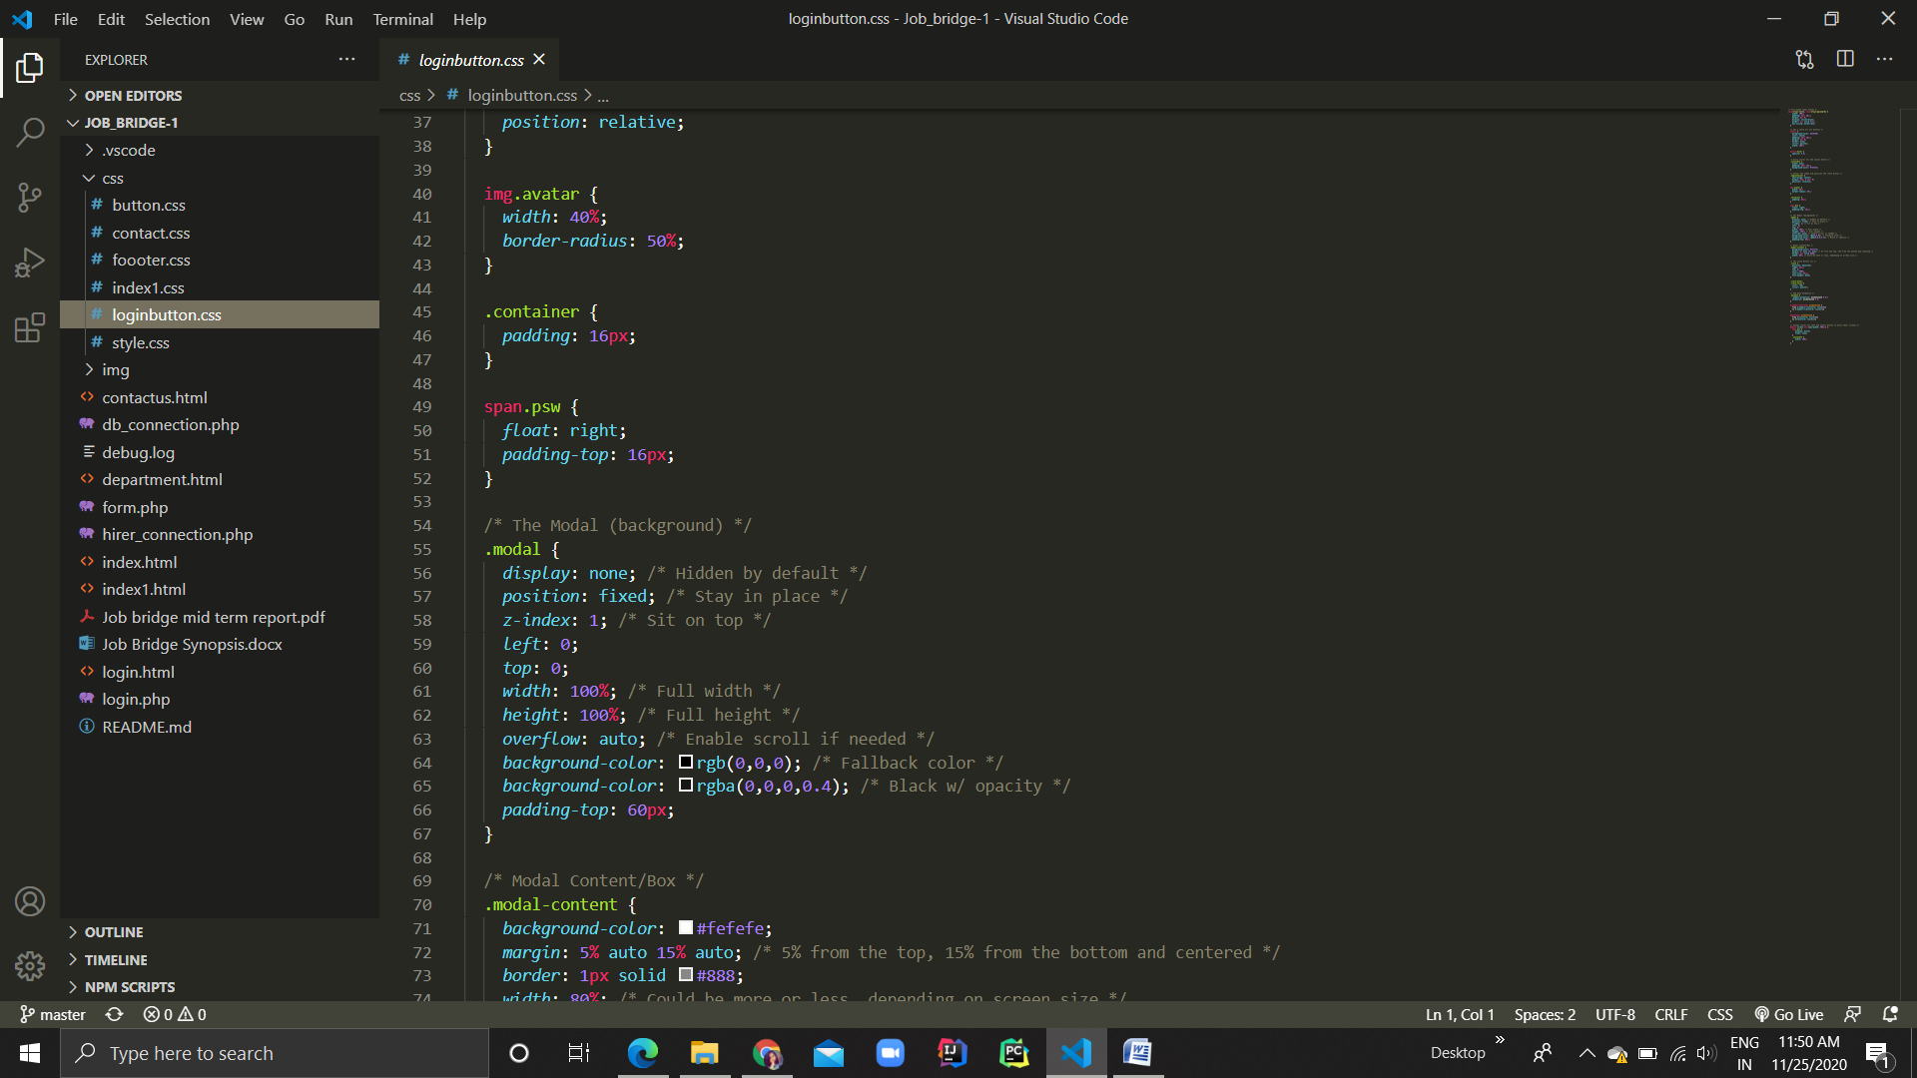

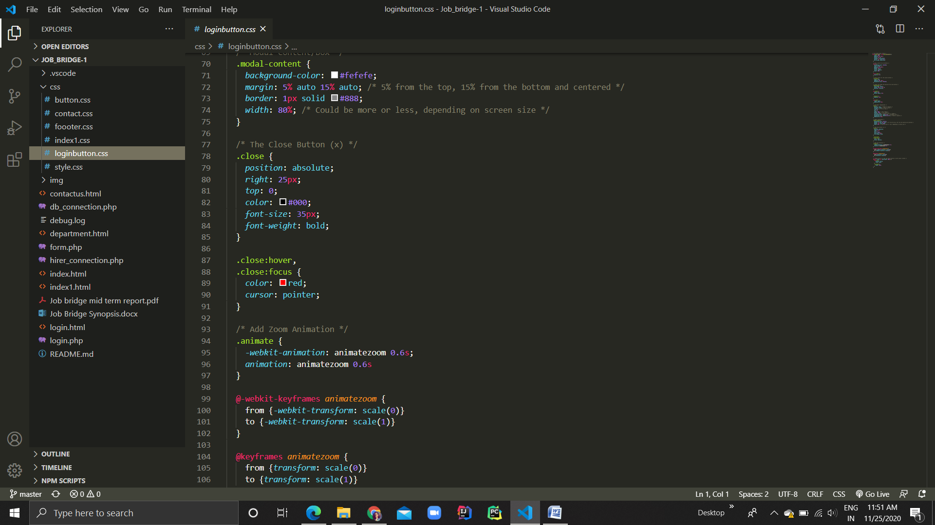

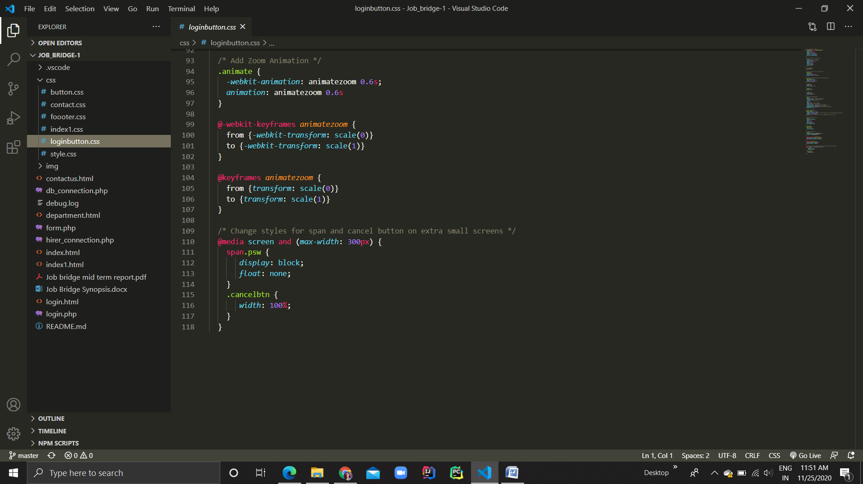

**Style.css**

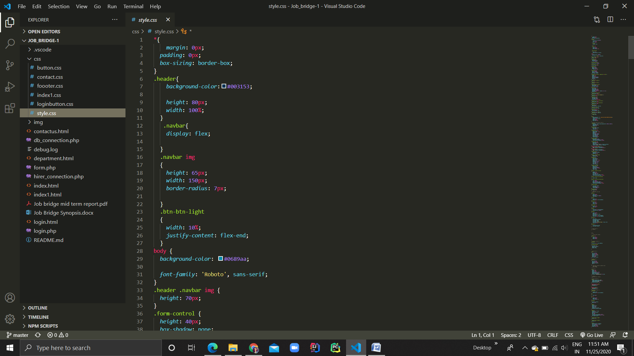

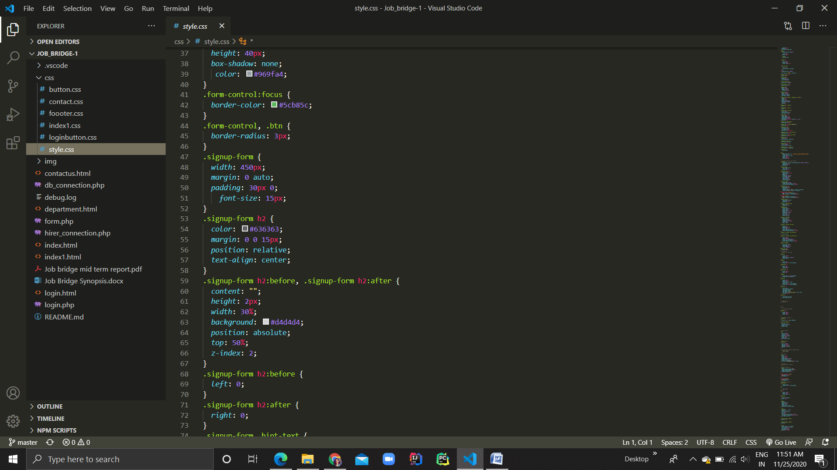

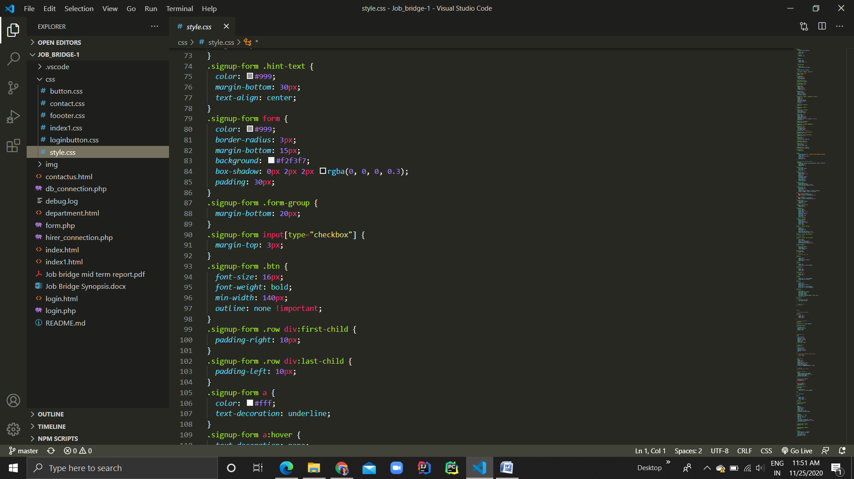

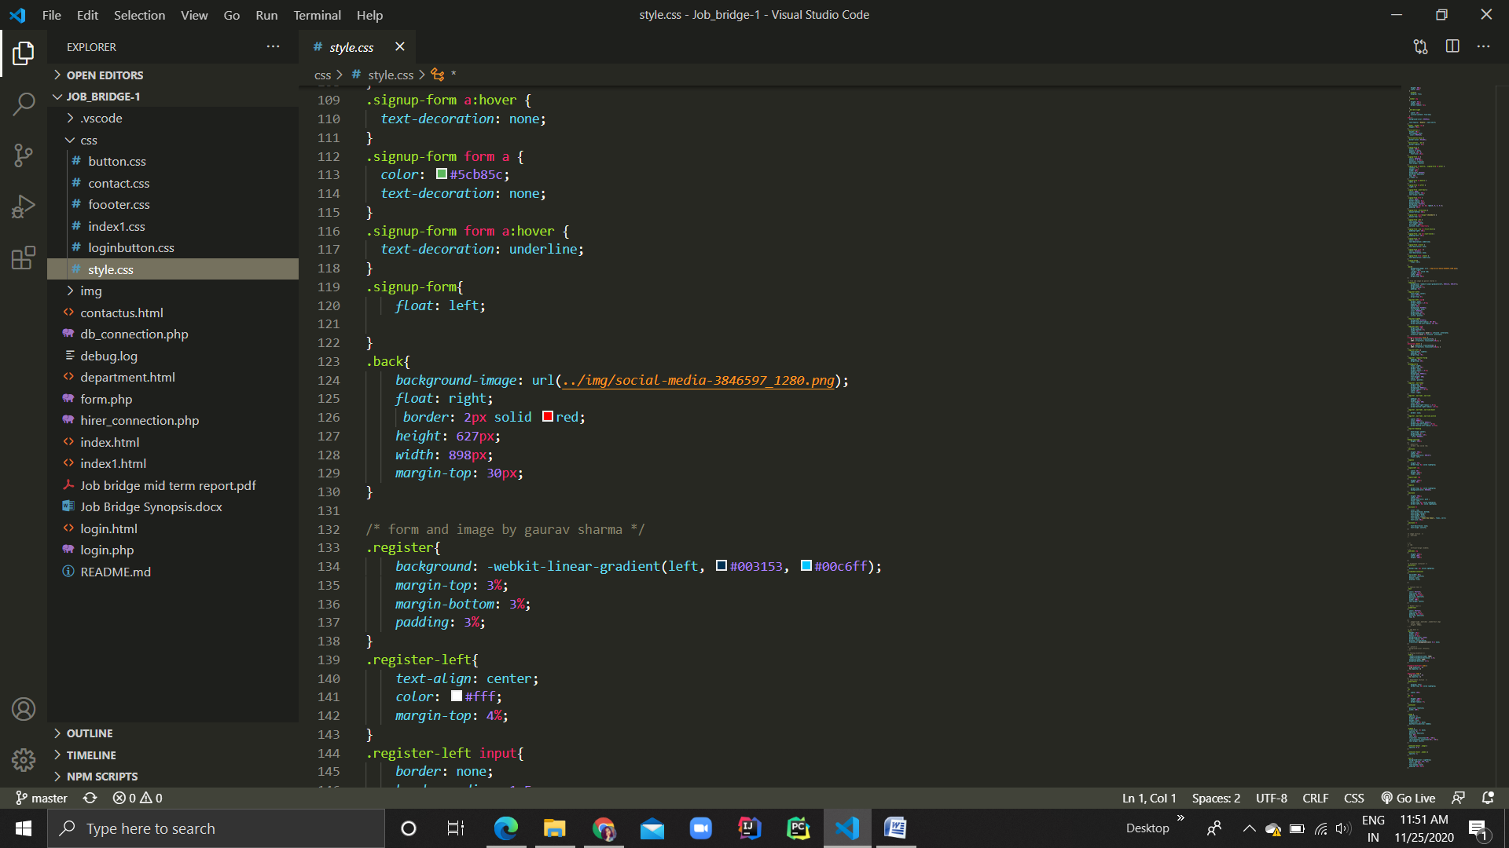

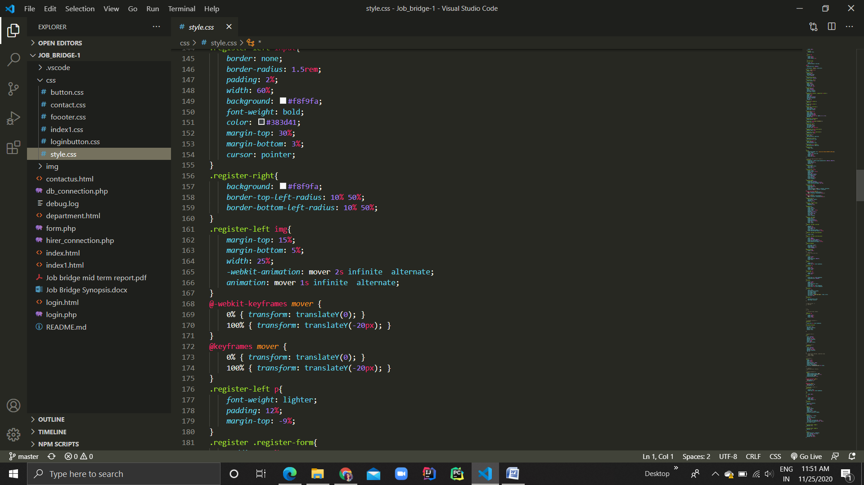

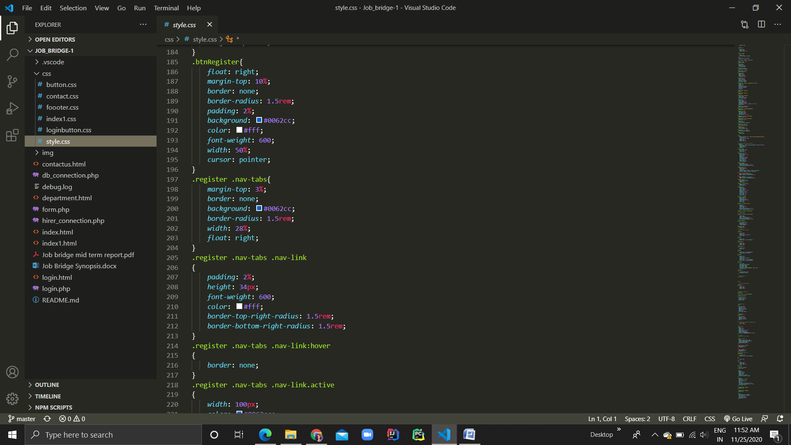

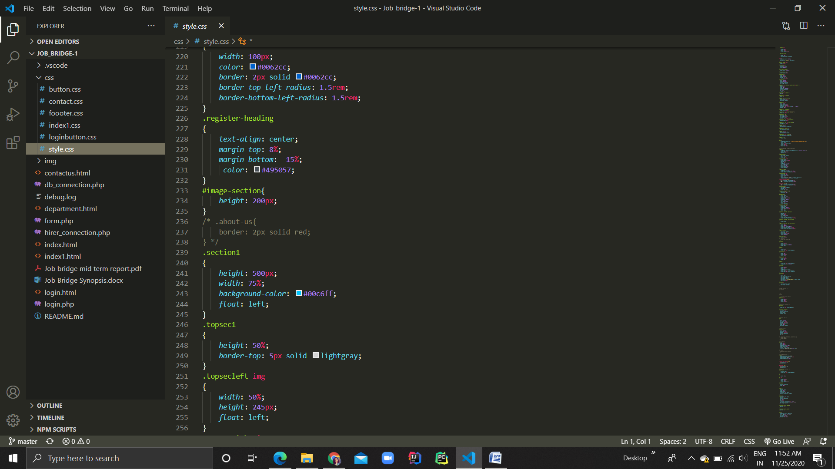

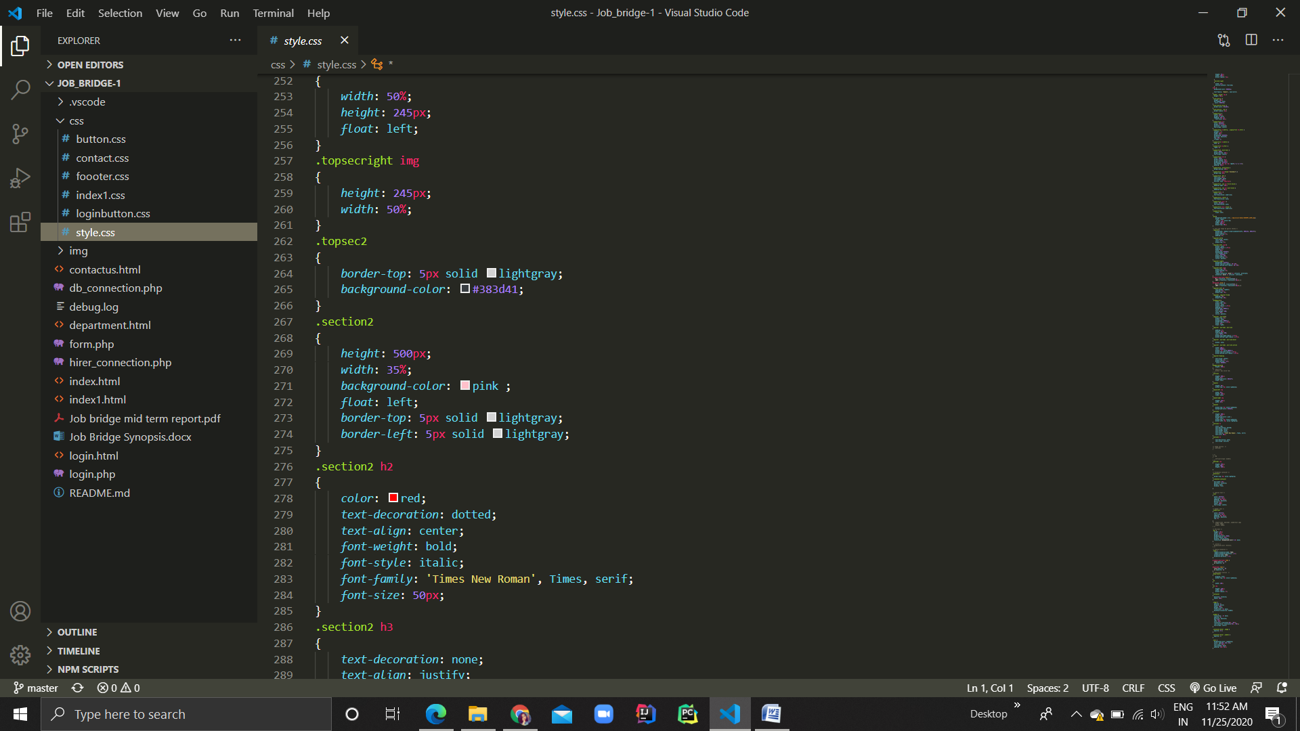

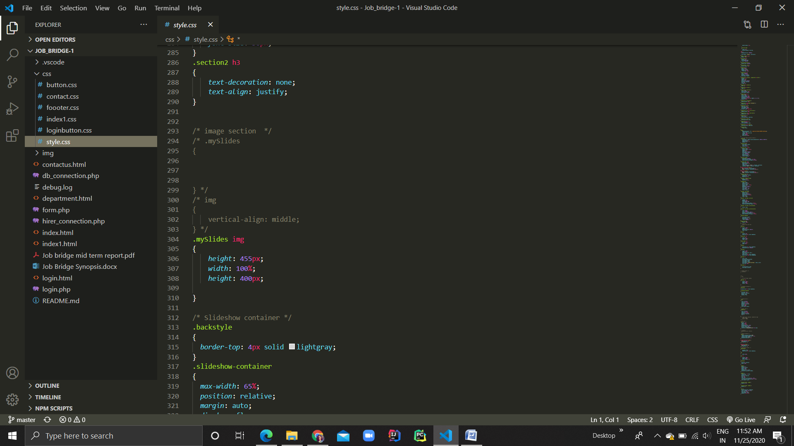

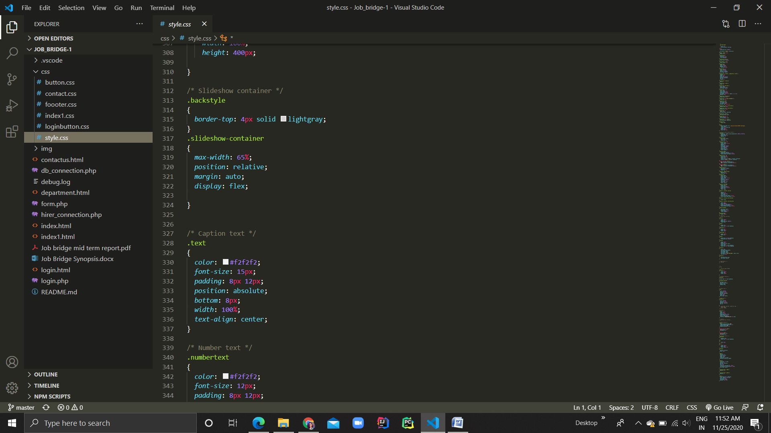

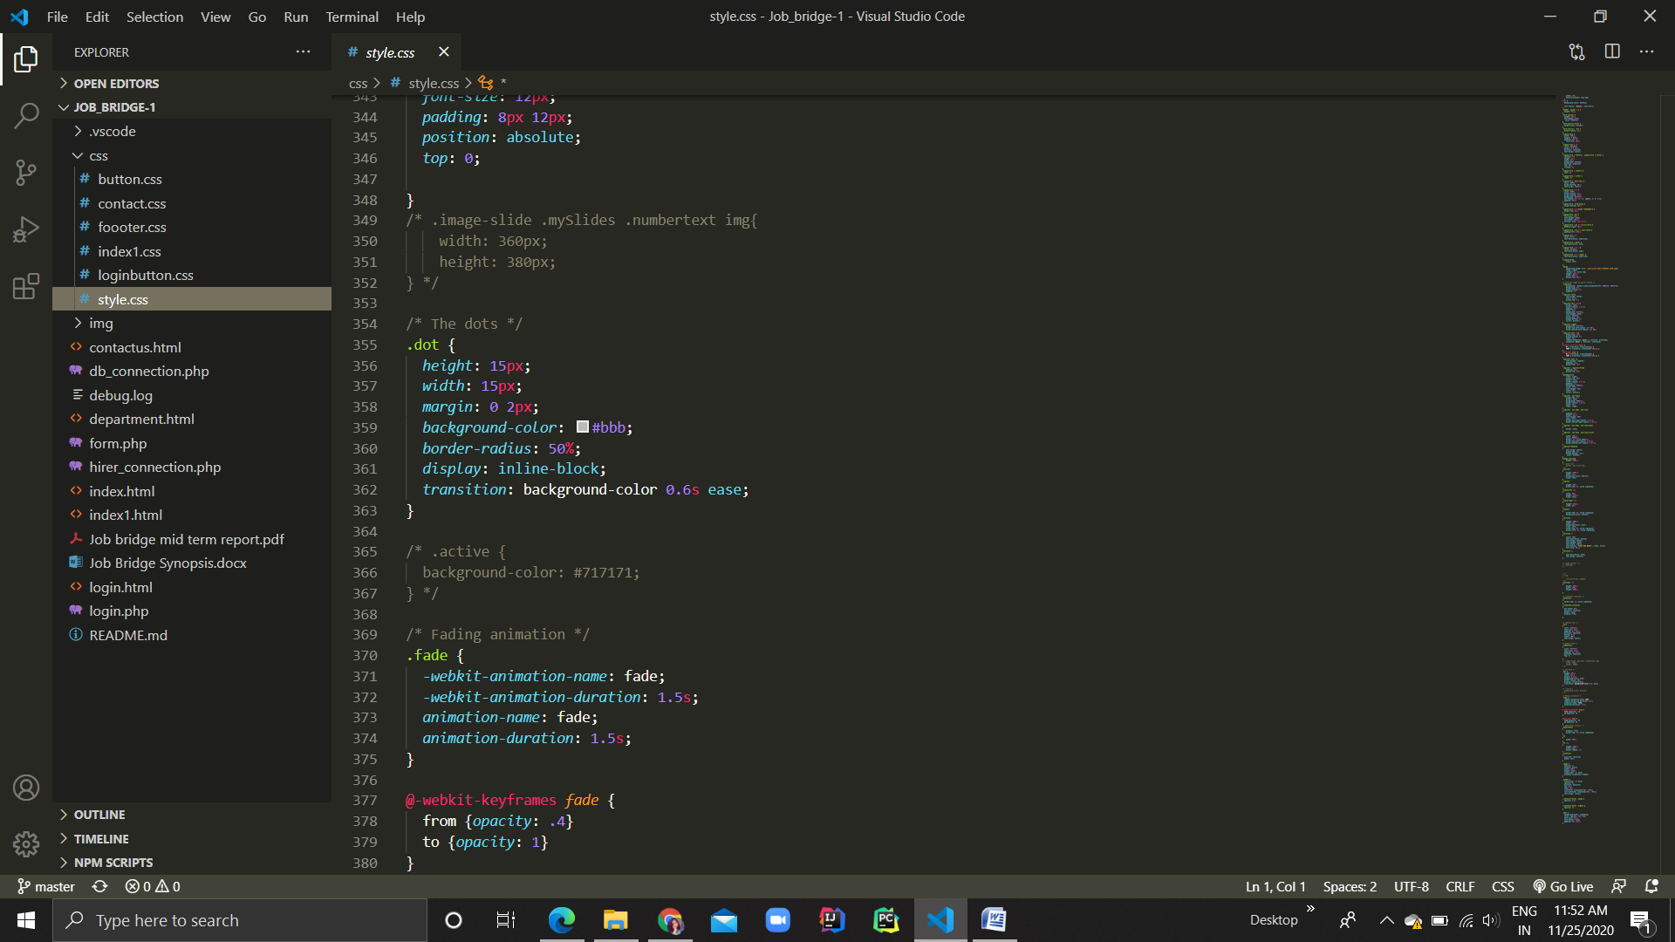

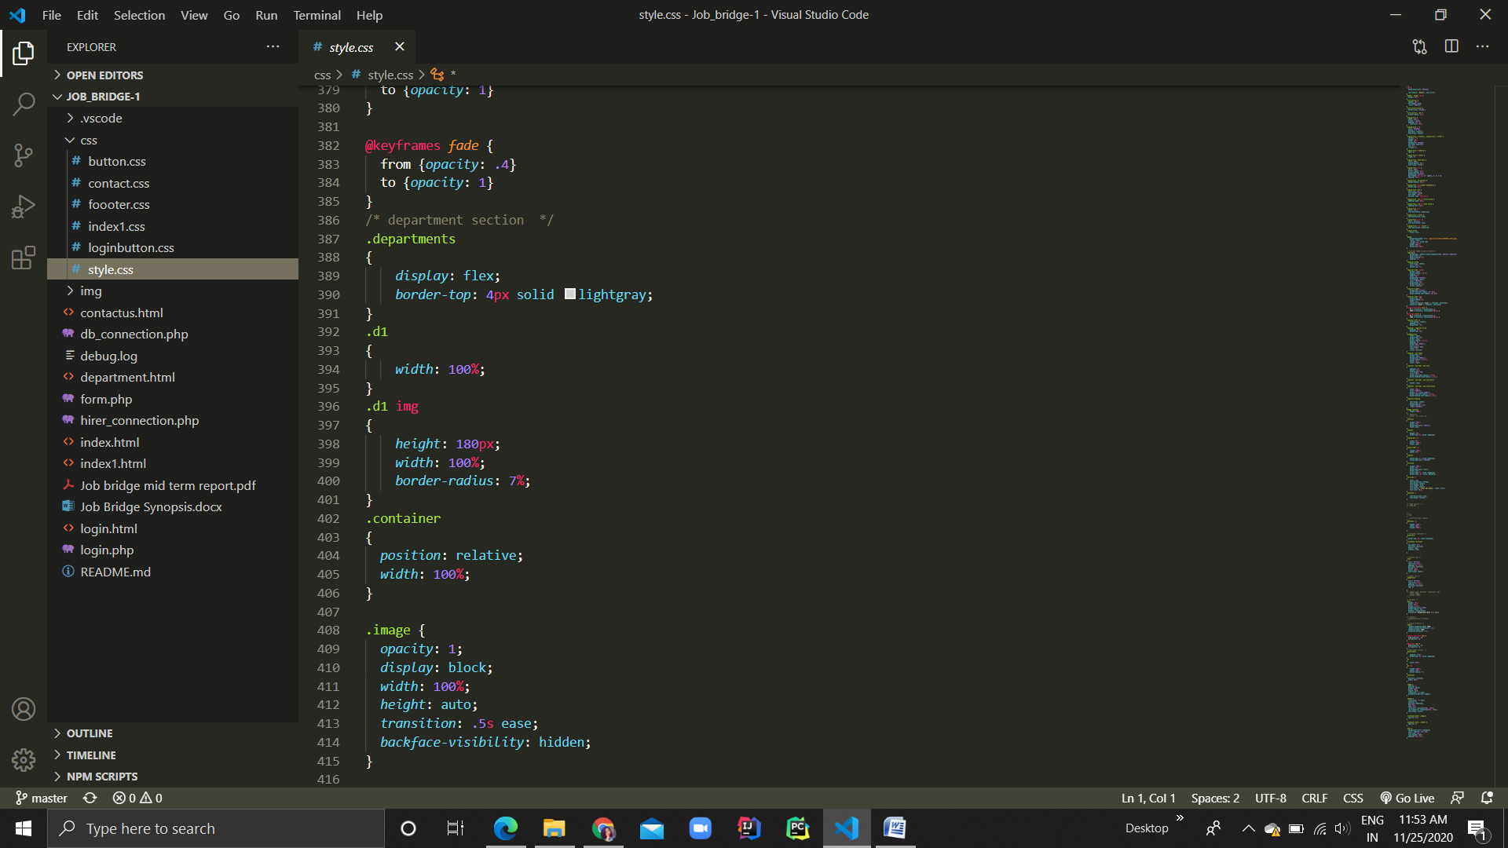

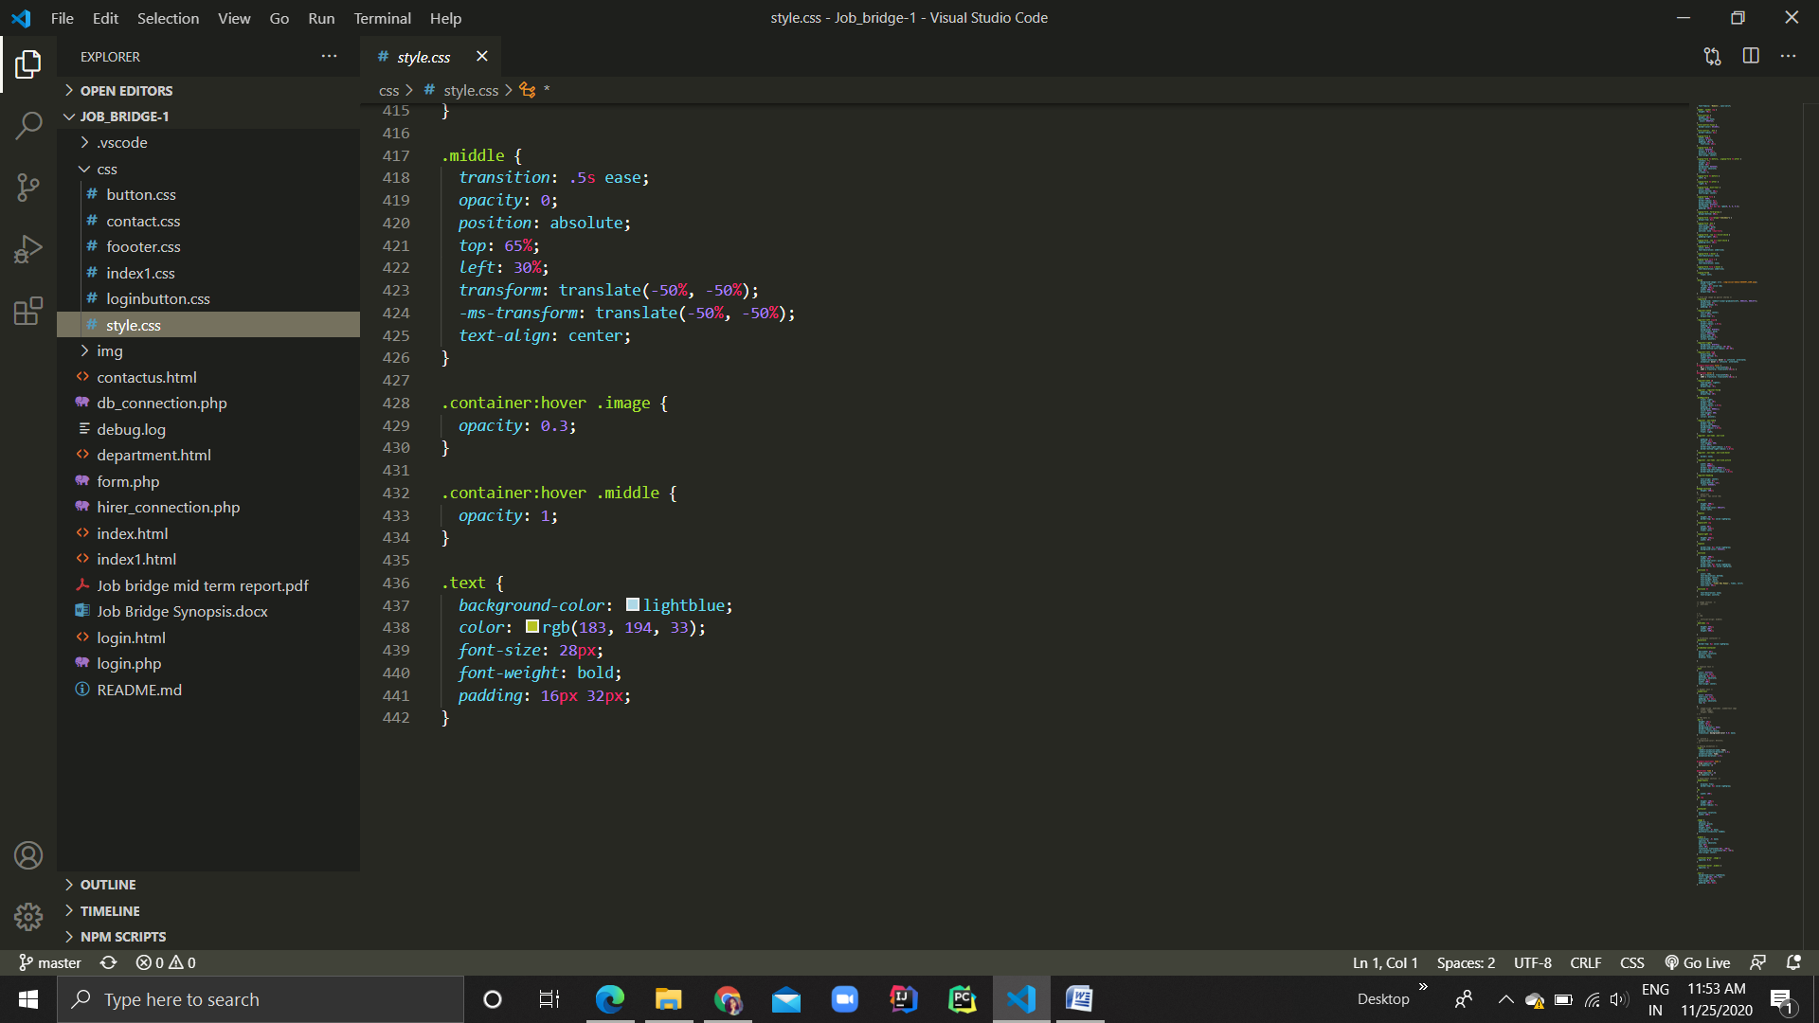

**Website images**

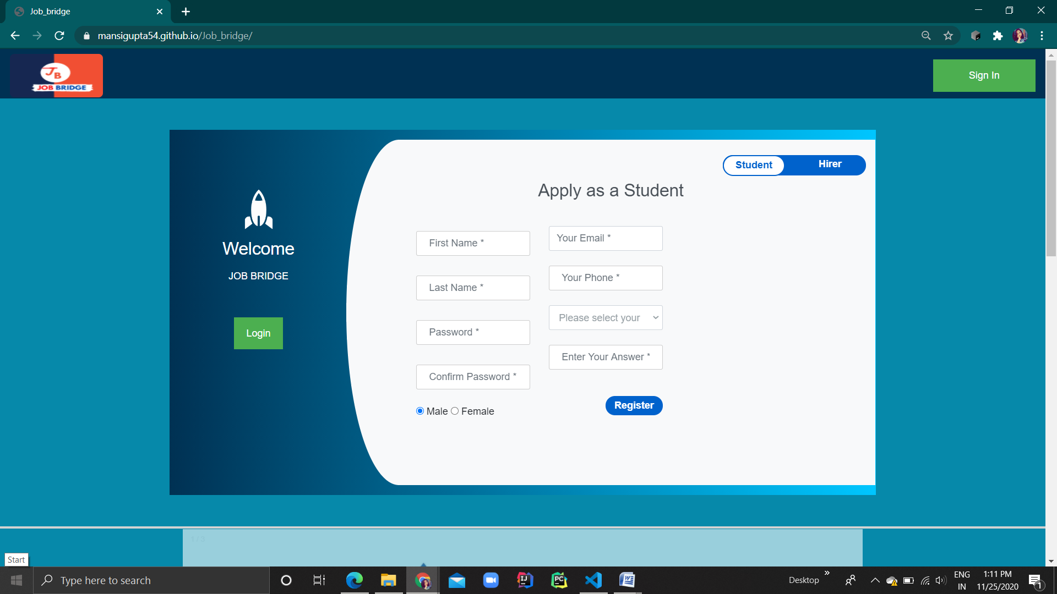

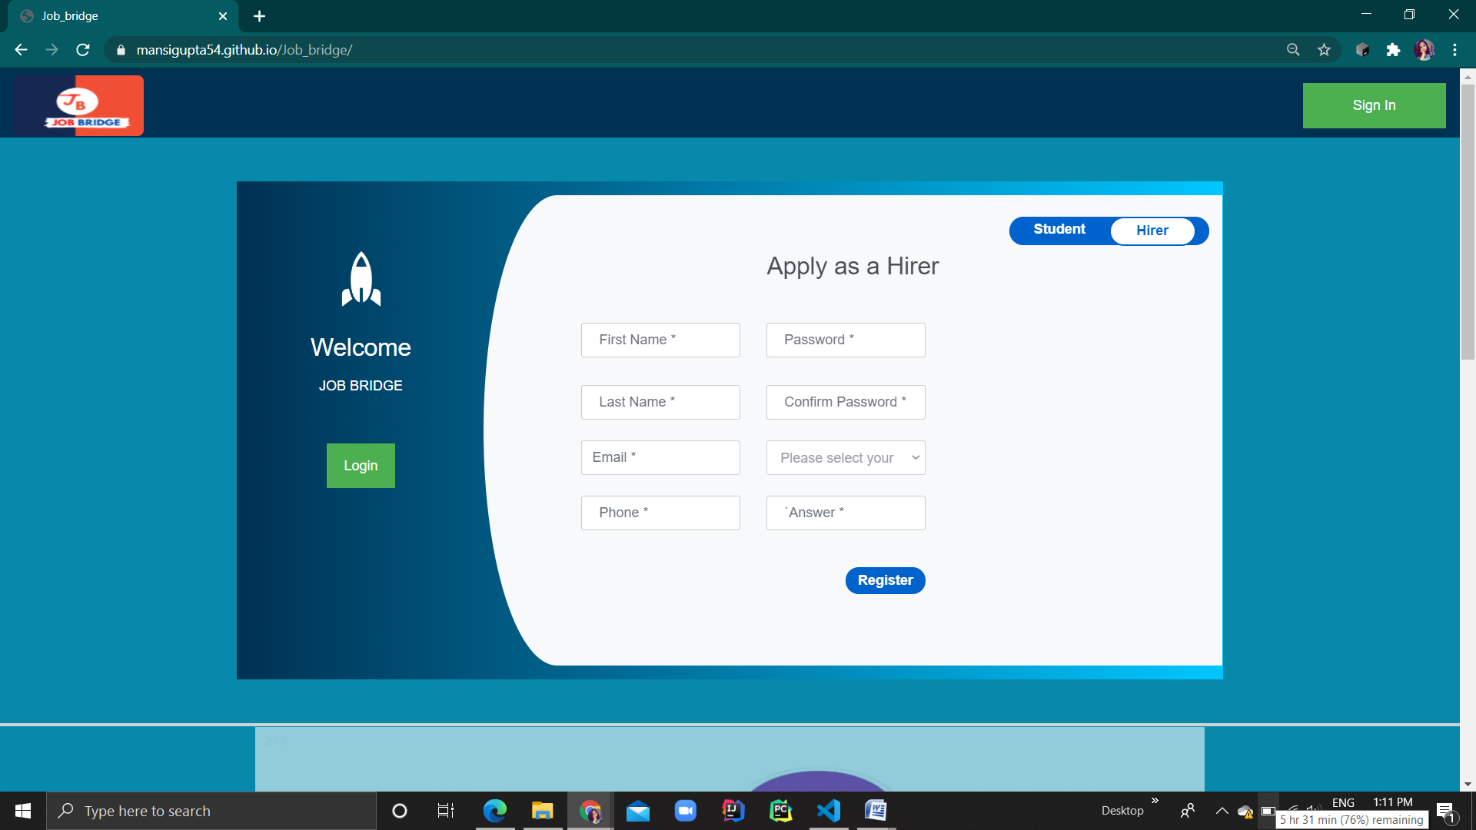

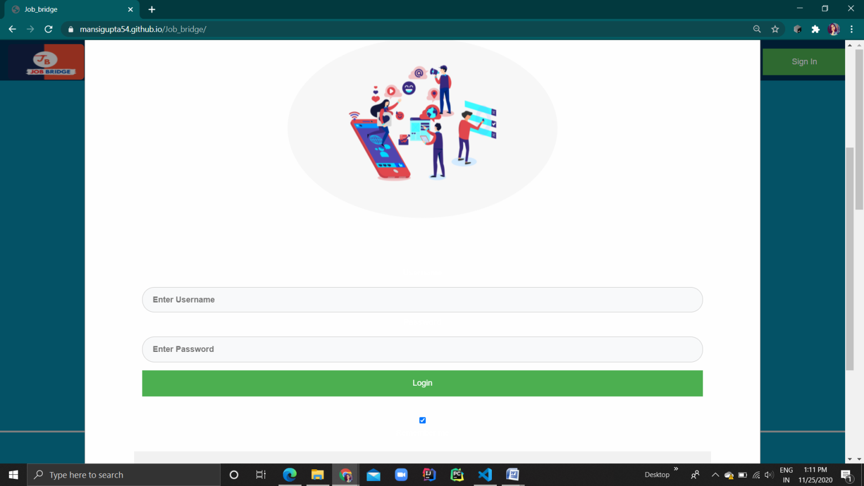

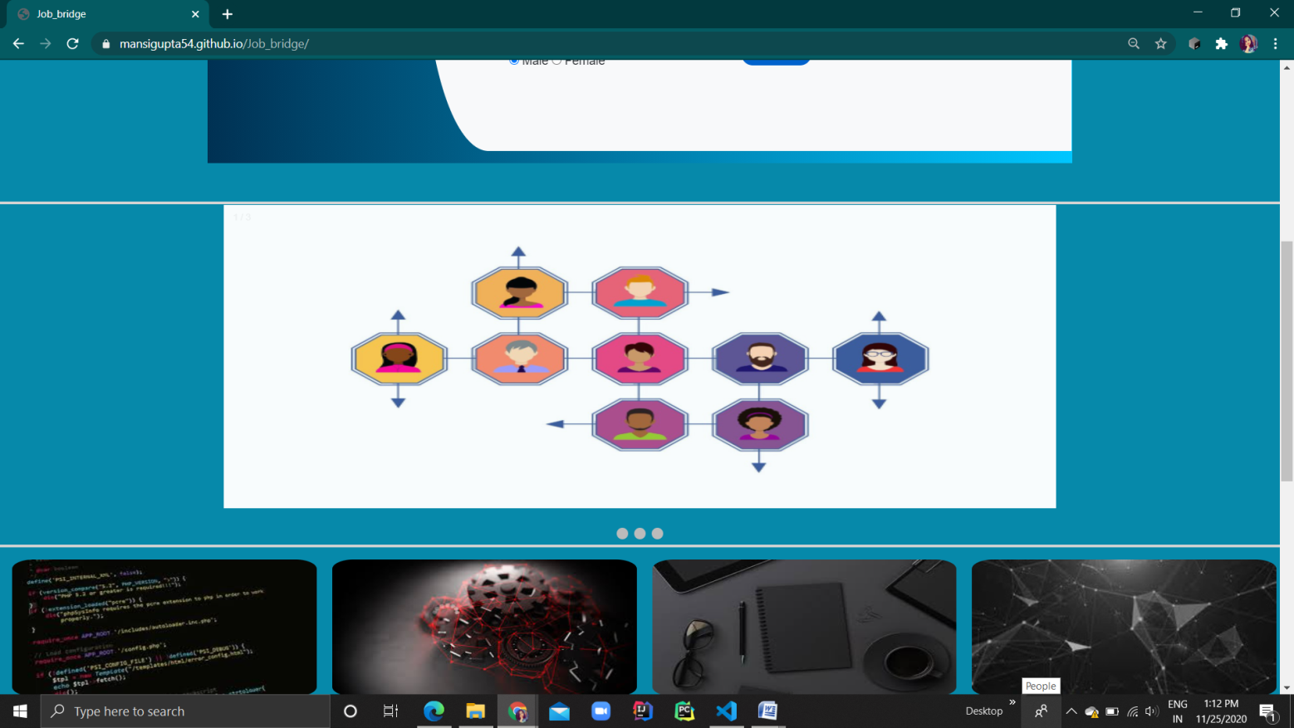

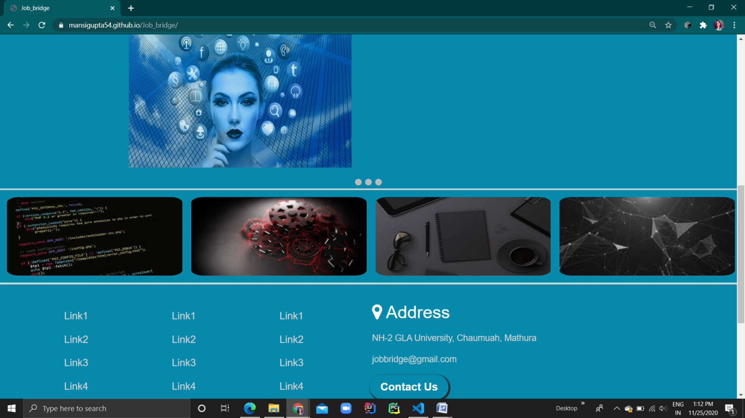

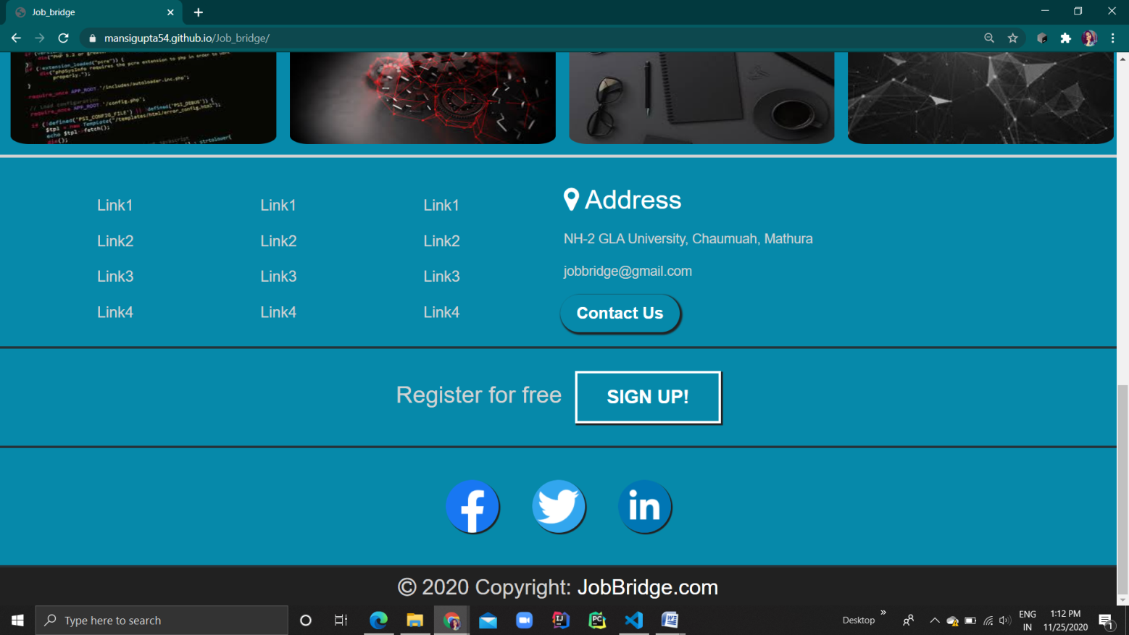

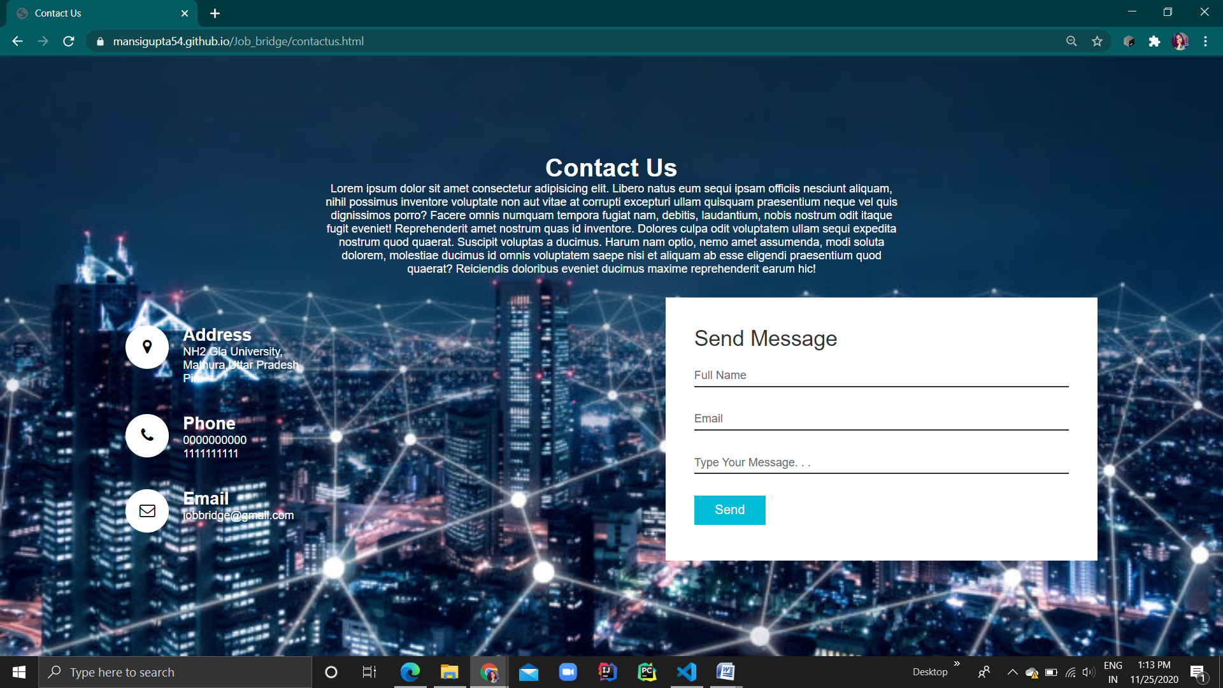

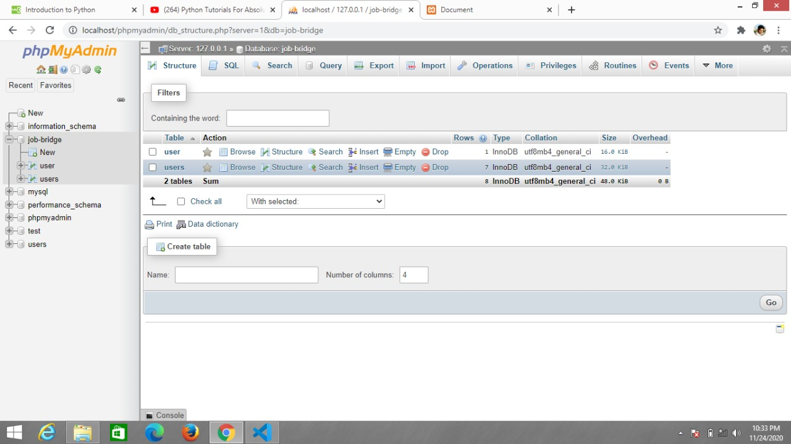

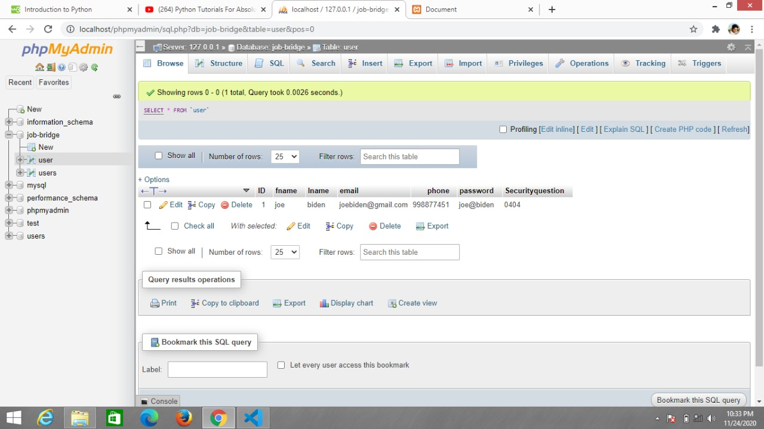

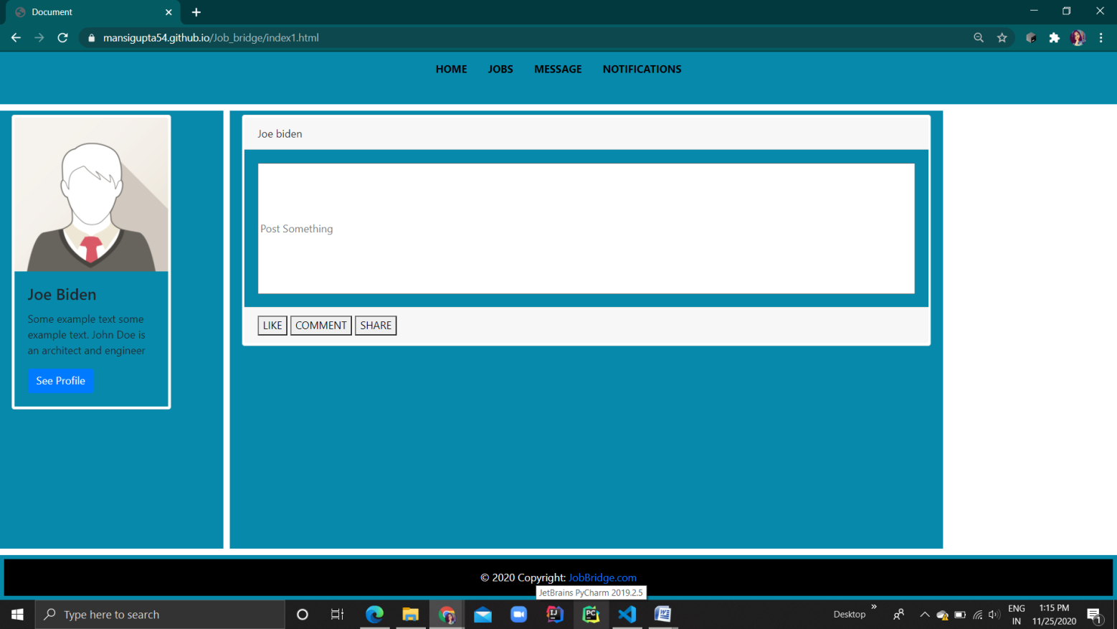

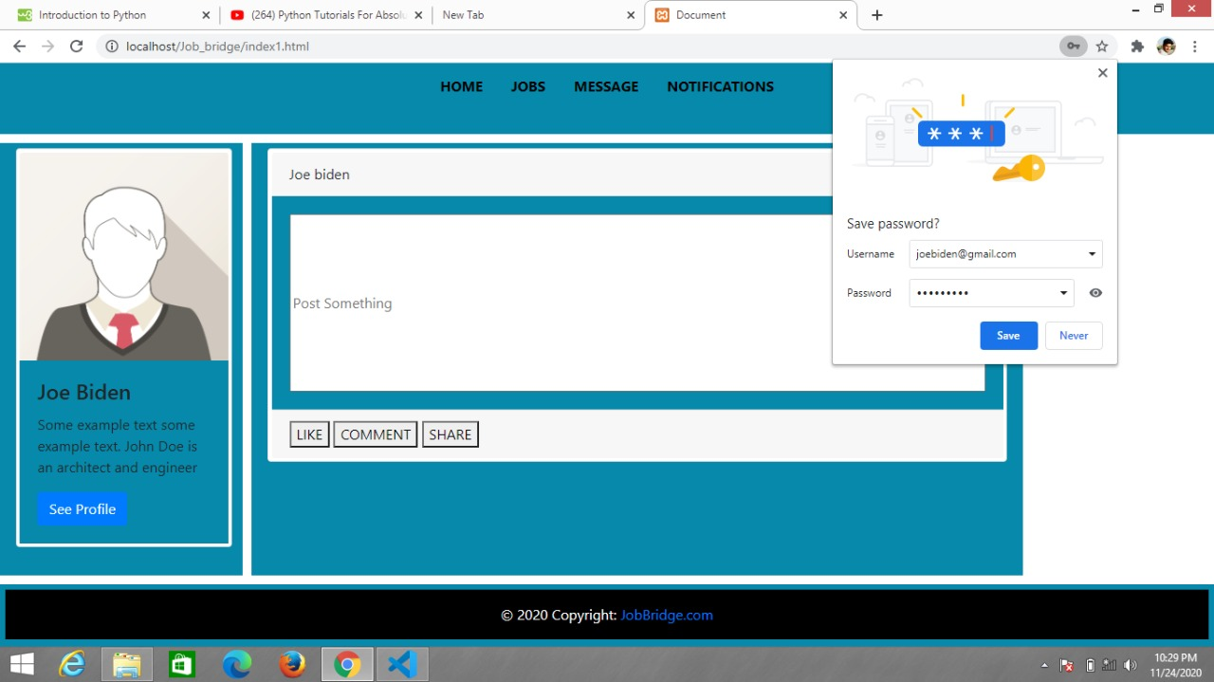

**References**

* + - * <https://www.w3schools.com/>
      * <https://stackoverflow.com/>
      * <https://www.tutorialspoint.com/>
      * https://www.youtube.com/